Location: Ray Township Hall
64255 Wolcott, Ray MI 48096

Present: Harold DeMan Jr., Chairman
Scott Mathews, Vice-Chairman
Marvin DeBuck, Secretary
Members: Tom Penzien
Betty Youngblood
Absent: None.

Also Present: Steve Cassin, Planning Consultant & Lisa Hall, Planning & Zoning Clerk
Attendance record on file.

- CALL TO ORDER- PLEDGE OF ALLEGIANCE AND ROLL CALL.
Chairman DeMan called the meeting to order at 7:00 p.m. The Pledge of Allegiance was recited.
All members were present.

- APPROVAL OF AGENDA
MOTION by Mathews supported by DeBuck to approve the agenda as presented.
MOTION carried.

- APPROVAL OF MINUTES: November 27, 2018
MOTION by Penzien supported by Youngblood to approve the meeting minutes of November 27, 2018 as presented.
MOTION carried.

- Scheduled Public Hearings-
Variance request for parcel currently known as 65625 Romeo Plank, Located northwest corner of Romeo Plank and 30 Mile Road. Property ID: 21-05-07-400-003. Marvel Owen Trust, Douglas Owen, Trustee, Rob Drewek, Representative, Applicant.
- Request to vary Section 400 – variance request of the required front yard setback off Romeo Plank

Chairman DeMan explained the public hearing procedure, the planner would explain the variance request so the audience will be informed on the variance request. Then the public hearing would be open for the public to come to the podium, state their name and address and state any comments they may have regarding the variance request.

MOTION by Penzien supported by Mathews to open the public hearing at 7:02 p.m.
MOTION carried.

Mr. Cassin, Planning Consultant presented his findings and recommendation dated December 5, 2018, they are as follows:
Applicant: Myrvle Owens Trust
Location: 65625 Romeo Plank (northwest corner of Romeo Plank and 30 Mile Rd.)
Zoning District: R-1, Agricultural Residential
Property ID: 21-05-07-400-003 (Case No. PZBA-18-009)
Size of Parcel: 59.50 acres of land
Action Requested: Request variance of the required front yard setback off Romeo Plank
PROPERTY CHARACTERISTICS
The property is located at the northwest corner of Romeo Plank and 30 Mile Road, is currently zoned R-1, and is developed with a single-family house and several out buildings. The house fronts Romeo Plank Rd. and is located approximately 1600 feet north of 30 Mile Road. The house is considered a non-conforming structure because it encroaches into the required front yard setback from Romeo Plank Road.
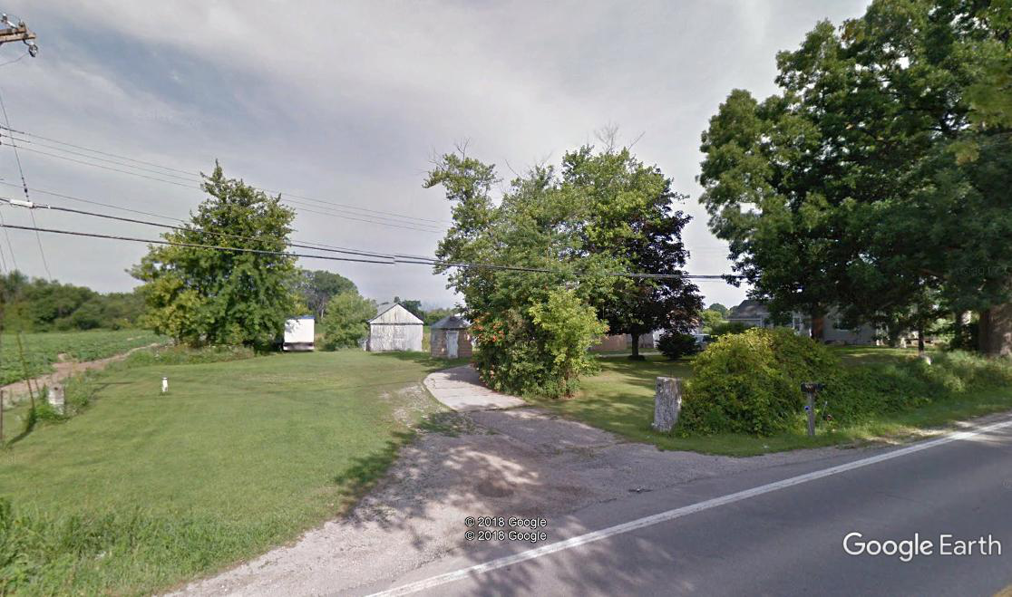
ANALYSIS OF VARIANCE REQUEST
The applicant is proposing to divide the existing 59.50 acre parcel into 9 different parcels. Section 6.00-E-1 of the Ray Township Land Division Ordinance states that no division of land shall be approved by the Township Assessor unless all township ordinance requirements, including zoning ordinance provisions, are complied with.

Section 1300 of the Ray Township Zoning Ordinance requires a 110’ setback from the centerline of Romeo Plank Road. The existing building, which is proposed to remain, has a setback of 73.2’. Therefore, a setback variance of 36.8’ is required.
The photo above generally depicts the location of the proposed site improvements in relation to the required setback lines.

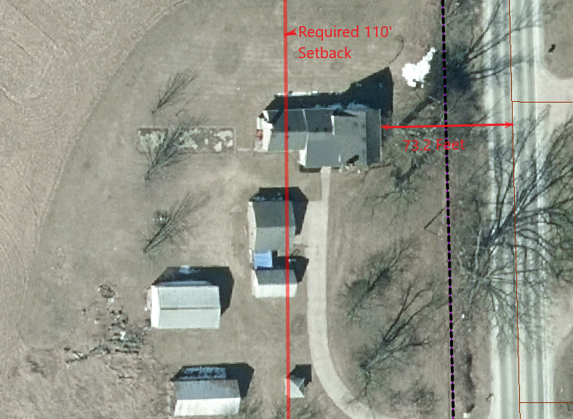

Road | Road Classification | Required Setback from centerline of Road | Existing Setback | Setback Variance Required
Romeo Plank | Major Road | 110’ | 73.2’ | 36.8’
AUTHORITY OF THE ZONING BOARD OF APPEALS
Section 2706 of the Ray Township Zoning Ordinance specifies that variances may be granted if the Zoning Board of Appeals finds that:
- The strict enforcement of the Zoning Ordinance would cause practical difficulty and deprive the owner of rights enjoyed by all other property owners owning property within the same zoning district.
- The conditions and circumstances are unique to the subject property and are not similarly applicable to other properties in the same zoning district.
- The conditions and circumstances unique to the property were not created by the owner or his/her predecessors in title, within the time following the effective date of the provisions alleged to adversely affect such property.
- The requested variance will not confer special privileges that are denied other properties similarly situation and in the same zoning district.
- The requested variance will not be contrary to the spirit and interest of the Township Zoning Ordinance.

Petitioner was present to answer any questions the Board may have.

Chairman DeMan read the correspondence as follows:
12-11-18 Dennis LeMieux, Building Official advised the existing building existed before the current zoning ordinance and was legal at the time it was built. The building department has no issues with the variance.

12-13-18 Kelly Timm, Township Assessor advised a variance is required to create the parcel with 12.32 acres. The existing house located on the proposed certificate of survey does not meet the required 110’ setback from the road. All other proposed splits have been reviewed by myself and the proposed splits meet the requirements of the land division act and Township Ordinances. If approved, the applicant is required to submit an application to the Assessor to process the split.

12-26-18 Jim Ternes, 65850 Romeo Plank, submitted a letter to the Zoning Board of Appeals, as follows:
“Attached is an aerial view of the proposed northern split and the Rumph’s Farm. This map shows an existing swale and 10’ drain that cuts though the northwest corner of proposed split. This is the only drainage for all the storm water south of 31 Mile on Romeo Plank.

The new owner’s should be informed that this must remain open until the county installs a drain down Romeo Plank to 30 Mile Road.”

MOTION by Penzien supported by Mathews to close the public hearing at 7:07 p.m.
MOTION carried.

DeBuck explained to the applicant if the variance is granted, the existing home could not be torn down and a new home constructed in the existing location. A new constructed home would have to comply with the Zoning Ordinance.
Penzien stated Mr. Ternes comments regarding the natural drainage of the property should be noted for the future property owners.

Mr. Cassin stated the issue would be addressed when a building permit would be issued by the Building Official and the Township Engineer for the drainage of the site.

MOTION by Penzien supported by DeBuck to Approve the Variance Request to vary Section 400- of the required front yard setback as requested for 65625 Romeo Plank for Parcel ID: 21-05-07-400-003 as recommended by the Planning Consultant based upon the recommendation, as follows:
The existing conditions are unique to property, have not been self-created, and is not contrary to the spirit and intent of the Zoning Ordinance. I recommend approval of the variance request.
FOR THIS MOTION: Yes: Penzien, DeBuck, Youngblood, Mathews, DeMan
No: None.
MOTION carried.

6. Report from the Planning Commission Representative
Penzien reported no meeting was held due to lack of agenda items.

7. Public Comments: None.

8. Adjournment
MOTION by Mathews supported by Youngblood to adjourn the meeting at 7:11 p.m.
MOTION carried.

Harold DeMan, Chairman Marvin DeBuck, Secretary Date

Respectfully submitted,
Lori R. Lascoe, Recording Secretary
Township Clerk

