Location: Ray Township Hall
64255 Wolcott, Ray MI 48096

Present: Harold DeMan Jr., Chairman
Scott Mathews, Vice-Chairman
Marvin DeBuck, Secretary
Members: Tom Penzien
Betty Youngblood

Absent: None.

Also Present: Jerome Schmeiser, Planning Consultant & Lisa Hall, Planning & Zoning Clerk
Attendance record on file.

- CALL TO ORDER- PLEDGE OF ALLEGIANCE AND ROLL CALL.
Vice-Chairman DeMan called the meeting to order at 7:30 p.m. The Pledge of Allegiance was recited. All members were present.

- APPROVAL OF AGENDA
MOTION by DeBuck supported by Youngblood to approve the agenda as presented.
MOTION carried.

- APPROVAL OF MINUTES: September 26, 2017 – Penzien corrected the motion on page 3 to close the public hearing.
MOTION by Mathews supported by Youngblood to approve the meeting minutes of September 26, 2017 as corrected.
MOTION carried.

- Scheduled Public Hearings-
- Request for a variance to Township Zoning Ordinance: Section 208 (Farm, Fish and Recreation Ponds or Aesthetic Landscaping Ponds); Located on the north side of 30 Mile Road, approximately 1/2 mile east of Wolcott Road. Permanent Parcel 05-10-300-014; Addresses of subject property 20625 30 Mile Road; Alyn F. Geno- Applicant.

Chairman DeMan explained the public hearing procedure, the planner would explain the variance request, so the audience will be informed on the variance request. Then the public hearing would be open for the public to come to the podium, state their name and address and state any comments they may have regarding the agenda item.

Mr. Schmeiser, Planning Consultant, presented his findings and recommendation, dated October 17, 2017. They are as follows:

The applicant is requesting a variance to allow existing parcel to be split in order to create a new parcel and allow an existing pond to remain within 50 feet of the property line of an abutting parcel. The pond is located on the parent parcel less than five (5) feet from the east property line and approximately 380 ft. from 30 Mile Road. The land division ordinance specifies that any resultant parcels of a split/combination must meet all provisions of the zoning ordinance. Therefore, the split/combination as proposed would be prohibited from being approved without obtaining relief from the Zoning Board of Appeals.
At the time of the house construction and pond development there was no regulation addressing a minimum distance that a pond must be from an abutting property line. The Zoning Ordinance as amended and adopted in 2011 established the regulation in the General Provisions Article; Section 208 that; “The pond shall be a minimum distance of fifty (50) feet from the property line of abutting lands.” As a result, the pond became a “Non-conforming use” and may remain in its present location as a Non-Conforming Use unless an action by the property owner triggers the removal of the non-compliant use. The applicant has decided to create a new split of the present parcel thus initiating an action that would trigger the requirement to make the pond compliant with Section 208 of the Zoning Ordinance.
The new parcel “Parcel B” measures 150’ x 750’ would be created off the west property line. Parcel B is not affected by the pond and will comply with the R-1 District of the Zoning Ordinance in all respects as a result of the proposed split. See Exhibit B, Land Division, and Proposed Conditions with Application documents.
Characteristics of the property can be summarized as follows:
Current zoning – R-1 agricultural Residential
Present Use – The existing parcel contains a single-family residence. The subject pond is in a general horse shoe shape and approximately 15,000 sq. ft. in area.

The general description of the surrounding properties is as follows:
The properties to east and west along both sides of 30 Mile Road contain single family residences on acreage parcels. (See aerial from Macomb County GIS below)
. 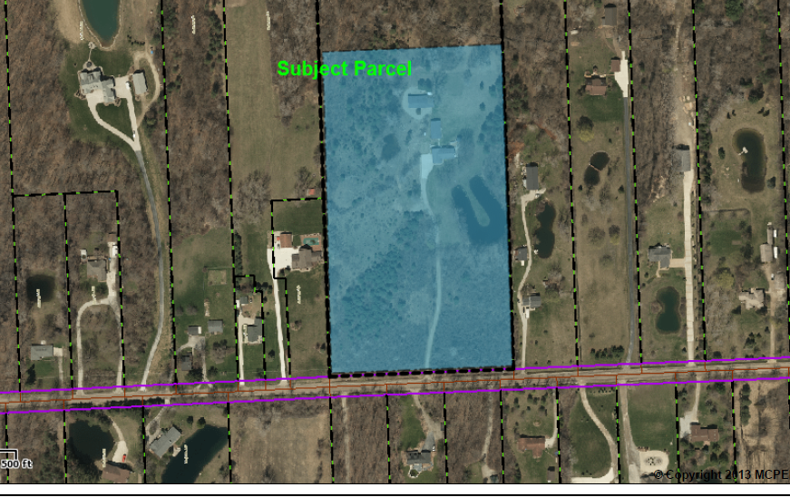

The Township Master Plan impacts subject property and the request as follows:
The Master Land Use Plan depicts the area as AGRICULTURAL/RESIDENTIAL 90,000 Sq. Ft.
The Master Thoroughfare Plan indicates that the future of 30 Mile Road is planned as a major thoroughfare with 120’of future R-O-W.
Wetlands: None identified
Gas Fields: None identified
Natural Features: None identified, none impacted
Floodplain: None identified
Woodlands: None identified, none impacted as being on Woodlands Map.
Watershed: Subject parcel is within the Tupper Brook Watershed

Recommendation to the Zoning Board of Appeals
It is recommended by the undersigned that the variance as requested should be denied for the following reasons:

- Compliance with the strict letter of the General Provisions Article relating to the location of ponds in relationship to adjoining lands requirements would not unreasonably prevent the ownership from dividing the existing parcel. Other parcels existing or to be created in Ray Township will be required to comply with the same General Provisions requirements relating to the digging of ponds which is evidence that the proper development in accordance with the Zoning Ordinance would not be unnecessarily burdensome.

- The granting of a variance as requested would give to the applicant an advantage or benefit not received by any other property owners in R-1 or other zoning districts in Ray Township. The other owners are or will be required to comply with the General Provisions Article relating to the location of ponds. As a result, the other property owners do not have the opportunity to locate a pond closer than 50 feet to an adjoining property line in an R-1 zone.

- There is nothing unusual about the parcel in question that sets it apart from other parcels in the area or in Ray Township. There is nothing to prevent any part of the General Provisions Article relating to the location of ponds from being met. For example, there is more than sufficient area on the parcel to re-establish the pond in compliance with the ordinance and further there are no significant grade differences or natural feature such as a stream or wetland to prevent full use of the parcel according to the ordinance as written.

MOTION by Penzien supported by DeBuck to open the public hearing at 7:39 p.m.
MOTION carried.

Alyn Geno, Petitioner stated they are requesting to create a two-and half acre parcel to give the property to her son. She explained her father owned 125 acres, in 1962 her father dug the pond and in 1965 he built the home she lives in over the years parcels were split off. In 1976, the parcel next to the pond was split off and sold. She stated she would like her son to be able to live on his grandfather’s property. Further stated it would cost fifteen thousand to fill in the pond the pond was in before the ordinance.

Michelle Kouri, 20861 30 Mile Road, stated she is the property owner two parcels over to the east. She stated she is in attendance because of the annual spring flooding in the area and believe the pond may be part of the issue to their property and Mr. Krajewski property. She explained the pond overflows and their yard is saturated with water from spring to early summer. She stated she hoped the applicant would provide drainage on the property and fill in the pond. Further requested the variance be denied.

Doug Kouri, 20861 30 Mile Road, provided photos to the Zoning Board of Appeals showing the flooding in the area.

Don Krajewski, 20823 30 Mile Road, stated he lives next door to the property and stated he feels the pond is the problem in the area. Further stated with the flooding in the area he can only use all of his property about two months of the year,

Bob Geno, Petitioner stated his neighbor, Mr. Krajewski asked for a drainage ditch along the property line and he provided the ditch to alleviate flooding in the area. Further stated the property in the area is low land.
Chairman DeMan stated two correspondences were received regarding the variance request as follows:

“My name is Donald Krajewski and I live at 20823 30 Mile Road. For the past 15 years, I have lived right next door and to the east of 20625 30 Mile Road. This parcel has a huge pond right on the property line and totally floods my back yard every spring. I can’t walk to my barn can’t get my vehicle out of the barn, and can’t cut grass until July when the pond starts to recede. If we get heavy rains in the fall, I have to deal with ice problems through the winter and thawing in the spring. My sump pump constantly runs because of this water, and in fact have burned out at least 8 pumps in 15 years.
Apparently there weren’t specific rules about digging a pond years ago. However, now that the owners want to split up this property into more parcels, it seems that the new Ray Township ordinances should apply.
- Ponds need to be within 50 feet from a property line of abutting lands.
- Any water overflow from a pond that could affect adjacent property should be provided with adequate drainage.
- Ponds should be constructed in a manner that runoff, overflow, spillage or seepage shall not encroach adjacent properties owned by another person.
I have dealt with flooding problems because of this pond all these years and something should be done for my benefit before allowing the property to be split up. Hopefully the Ray Township Zoning Board follows their pond ordinances when considering the variance request.”

10-18-17 Bob Beckett, Building Official, comments as follows:
“ZBA variance for parcel known as 20625 30 Mile Road, Parcel 05-10-300-014 to be split into two (2) parcels. If approved the variance would allow the existing pond on Parcel A to remain less than fifty (50) feet from abutting parcel.
The building department recommends this variance to be denied because the improvements of the property can be corrected so compliance to the ordinance can be met. It would be unfair to the rest of the community to allow a pond to be less than the requirements of the ordinance when the township has made other properties comply, even if the pond had to be moved.”

MOTION by Penzien supported by Youngblood to close the public hearing at 7:51 p.m.
MOTION carried.

Penzien asked if there is artisan well on the site. He stated the Board received a certified surveyed plan and the plan shows a drain.

Bob Geno, Petitioner stated in the fall the pond level goes down in the fall. Further stated there is a farmer’s ditch on the property.

Penzien stated Ray Township has many farmers’ ditches which are water courses to have the water flow in the area. He stated he visited the area and measured the 24” culvert under 30 Mile Road and the 18” culvert on how the water flows in the area. He stated he does not feel there would be a difference in the in the area if the pond was not dug. Further stated the pond was dug before the ordinance and does not feel the pond is the issue of the flooding.

DeMan stated he is aware of the flooding and knows there is a drain in the area.

Mathews stated the pond holds approximately 15,000 square feet of water and if the pond was not there the area would still flood.

DeBuck stated the pond is supposed to be for run-off. Further stated if the area was farmed there would be farmer’s ditches to have the water flow.
Lengthy discussion was held on the flooding in the area and the water course.

Penzien stated there are practical difficulties and feels the variance should be granted.

DeBuck stated if the variance was granted the Township should throw-out the ordinance.

Penzien stated he does not feel the Board would be creating a problem since the pond was dug in 1962.

Mathews stated the last split was in 1972 according to the planners’ report.

Penzien asked if the Supervisor could work with the County on the flooding in the area.

MOTION by Penzien supported by Mathews to Approve the Variance to vary Section 208 (Farm, Fish and Recreation Ponds or Aesthetic Landscaping Ponds); Located at 20625 30 Mile Road, Located on the north side of 30 Mile Road, approximately ½ mile east of Wolcott Road for Permanent Parcel No. 05-10-300-014, with the understanding that the applicant shall comply with Section 208 and shall provide warning signs and lifesaving equipment, as required by the State of Michigan:
- Required sign – “Warning Deep Water”
- Life ring with rope you can throw to the middle of the pond.
FOR THIS MOTION: Yes: Penzien, Mathews, Youngblood, DeMan.
No: DeBuck.
MOTION carried.

Zoning Board of Appeals recommends the Township Supervisor look at the flooding in the area as discussed.

6. Report from the Planning Commission Representative – Penzien reported the Planning Commission did not have a meeting due to lack of agenda items.

7. Public Comments: None.

8. Adjournment
MOTION by DeBuck supported by Youngblood to adjourn the meeting at 8:23 p.m.
MOTION carried.

Harold DeMan, Chairman Marvin DeBuck, Secretary Date

Respectfully submitted,
Lori R. Lascoe, Recording Secretary
Township Clerk

