Location: Ray Township Hall
64255 Wolcott, Ray MI 48096

Present: Harold DeMan Jr., Chairman
Scott Mathews, Vice-Chairman
Tom Penzien
Betty Youngblood
Marvin DeBuck, Secretary

Absent: None

Also Present: Stephen Cassin, Planning Consultant & Lisa Hall, Planning & Zoning Clerk
Attendance record on file.

- CALL TO ORDER- PLEDGE OF ALLEGIANCE AND ROLL CALL.
Chairman DeMan called the meeting to order at 7:00 p.m. The Pledge of Allegiance was recited. All members were present.

- APPROVAL OF AGENDA
MOTION by Penzien supported by Mathews to approve the agenda as presented.
MOTION carried.

- APPROVAL OF MINUTES: September 25, 2018
MOTION by Mathews supported by Youngblood to approve the meeting minutes of September 25, 2018 as presented.
MOTION carried.

- Scheduled Public Hearings-
Request for the following variances to Township Zoning Ordinance: Section 400
(R-1 Agricultural Residential; Lot Dimensions 1). Minimum Lot area and 2). Minimum Lot Width and 3). Section 200 Accessory Buildings in Residential Districts, A, allow existing accessory structure to remain without a principal structure.

Chairman DeMan explained the public hearing procedure, the planner would explain the variance request so the audience will be informed on the variance request. Then the public hearing would be open for the public to come to the podium, state their name and address and state any comments they may have regarding the agenda item.

MOTION by Penzien supported by Youngblood to open the public hearing at 7:02 p.m.
MOTION carried.

Mr. Cassin, Planning Consultant, presented his findings and recommendation, dated November 13, 2018. They are as follows:

GENERAL INFORMATION:

Applicant: Keith Mc Laughlin
Location: 64505 Wolcott (west side of Wolcott, south of 30 Mile Road)
Zoning District: R-1 Agricultural Residential
Property ID: 21-05-16-200-048 (Case No. PZBA-18-007)
Size of Parcel: 1.97 acres of land
Action Requested: Request to split property resulting in lot size less than required, lot widths less than required, and an accessory structure on a lot without a principal structure.

PROPERTY CHARACTERISTICS:
The property is currently zoned R-1, Agricultural Residential, and contains a 3,358 square foot single-family home, and a 1,925 square foot detached accessory structure. The property also has a 20-foot easement containing a gravel drive to access property to the rear (west).
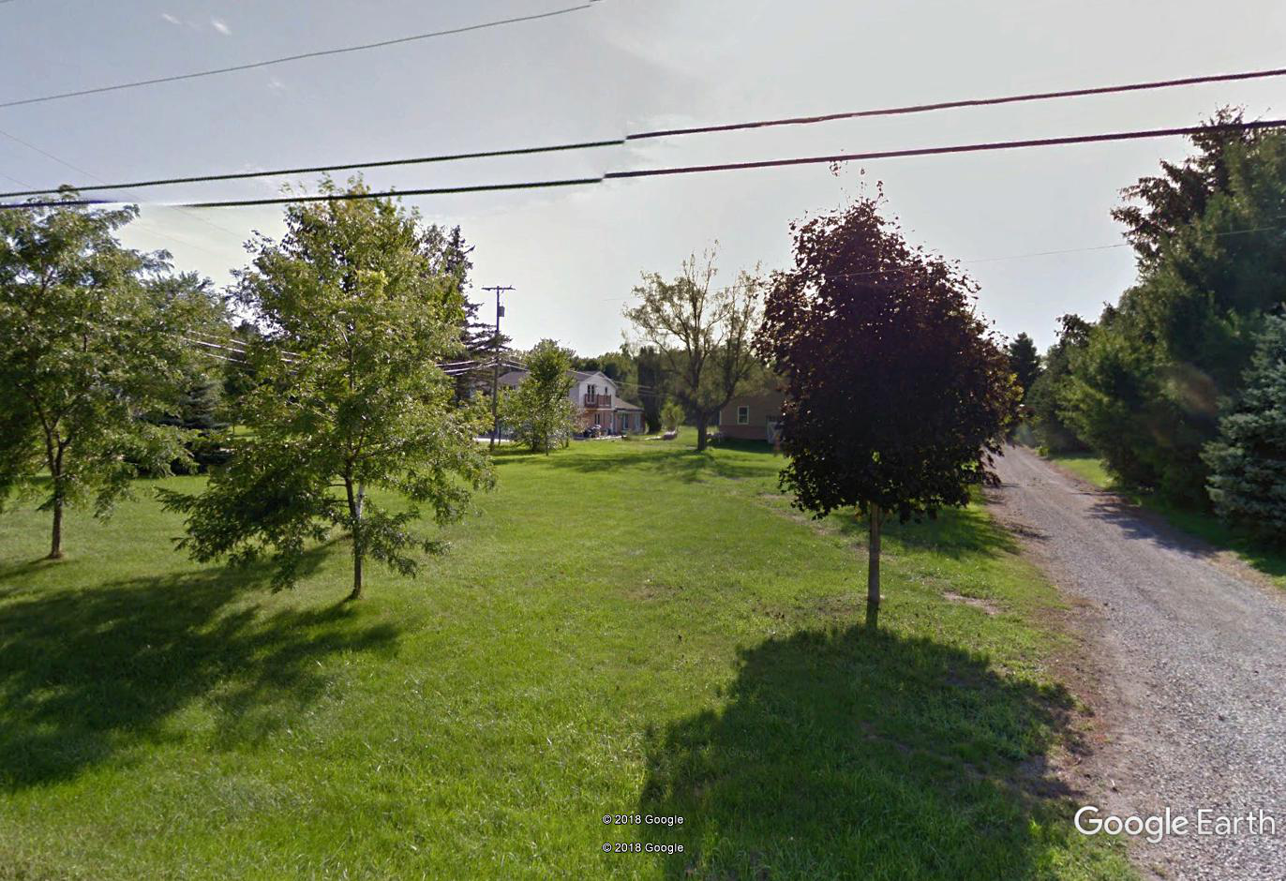
ANAYLSIS OF THE VARIANCE REQUEST:
The applicant is requesting to split the property into 2 separate parcels, both with frontage on Wolcott Rd. Parcel 1 would be .97 acres in area (42,253 square feet), have a frontage of 103.39 feet, and contain the existing accessory structure (barn). Parcel 2 would be 1.0 acre in area (43,560 square feet), have a frontage of 107.55 feet, and contain the existing single-family structure.
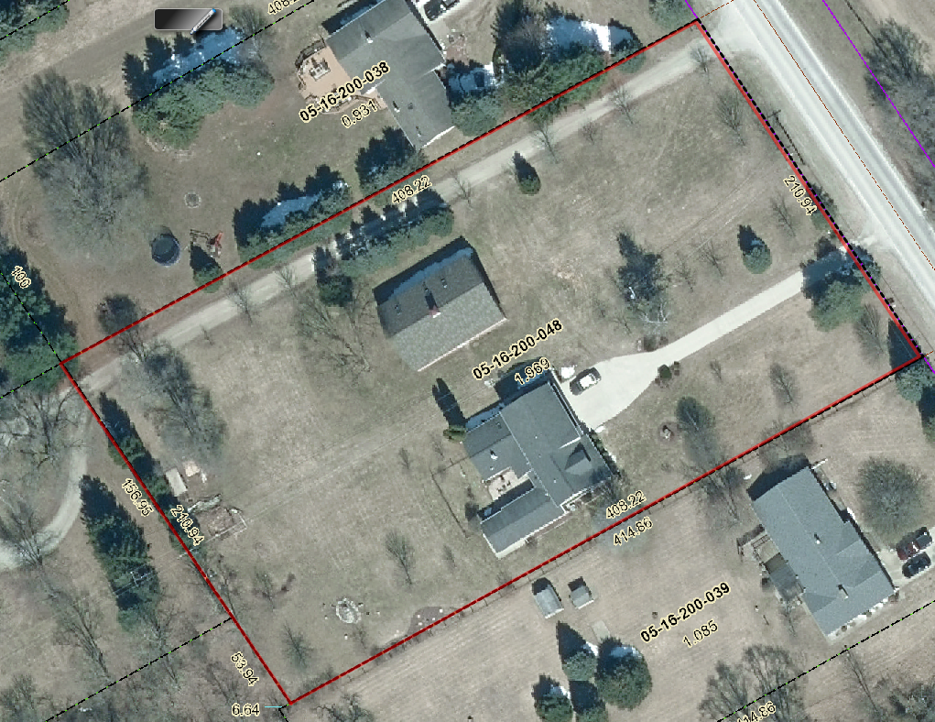
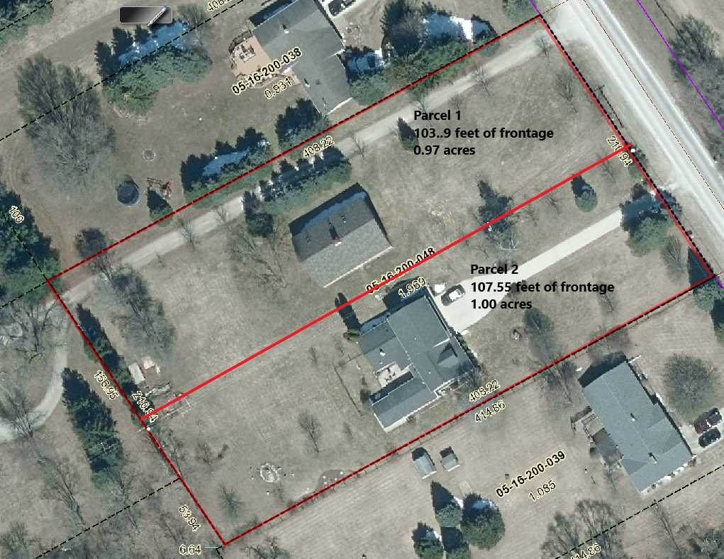
Section 400 of the Ray Township Zoning Ordinance requires a minimum lot size of 90,000 square feet and a minimum lot width of 150 feet. Both parcels are non-compliant with these requirements.
Section 200 A of the Ray Township Zoning Ordinance specifies that “accessory buildings or structures in all residential districts shall be customarily incidental to and subordinate in size and scope to the principal building”. The proposed lot split would place the accessory building on a separate parcel of property which is not allowed.
To summarize, in order to approve the lot split, the following variances would be required:
- A variance to allow 2 parcels, each having a total land area less than the required 90,000 square feet.
- A variance to allow 2 parcels, each having a width less than the required 150 lineal feet.
- A variance to allow an accessory building on property not having a principal dwelling.
AUTHORITY OF THE ZONING BOARD OF APPEALS:
Section 2706 of the Ray Township Zoning Ordinance specifies that variances may be granted if the Zoning Board of Appeals finds that:
- The strict enforcement of the Zoning Ordinance would cause practical difficulty and deprive the owner of rights enjoyed by all other property owners owning property within the same zoning district.
- The conditions and circumstances are unique to the subject property and are not similarly applicable to other properties in the same zoning district.
- The conditions and circumstances unique to the property were not created by the owner or his/her predecessors in title, within the time following the effective date of the provisions alleged to adversely affect such property.
- The requested variance will not confer special privileges that are denied other properties similarly situation and in the same zoning district.
- The requested variance will not be contrary to the spirit and interest of the Township Zoning Ordinance.
RECOMMENDATION:

The requested variances do not appear to meet the requirements listed above. Specifically, there is nothing unique to the property that would suggest a variance is necessary, and the need for the variance is self-created. Therefore, without evidence to the contrary, I recommend denial.

Chairman DeMan read the following correspondence into the record:
11-13-2018 Dennis LeMieux, Building Official, The variance request for 64505 Wolcott is asking for a lot split which would result in 2 lots, one at 103 feet wide, the other 107 feet wide. If approved, the resulting lots would be half of the required 90,000 square feet required in the ordinance in section 400 page 4-1. I recommend denial. In regards to the allowing of an existing accessory structure on a lot with no primary structure, I recommend denial.
11-13-2018 Kelly Timm, Assessor, RE: ZBA Variance 05-16-200-048, The assessing department has reveiwed the request for the varainces requested on the above referenced parcel. A varaince is required to create Parcel 1 and Parcel 2. Both lots do not meet the required 150‘ frontage and 90,000 square feet. A variance is also required to leave the existing barn on a vacant piece of property.
If approved, the applicant is required to submit an application to the Assessor to process the split.
If you should have any questions regarding this information, please feel free to contact me.
Mr. DeMan asked the applicant if he had would like to address the Zoning Board Of Appeals?
Mr. McLaughlin asked if any correspondance had been received from the Huron Clinton Metro Park? He was advised no correspondance had been received from HCMA.
Mr. McLaughlin stated that he should have torn the house down when he bought it, he has invested $400,000 into the property. He hoped that one day he would be able to split the lot due to the sizes of the surrounding parcels. He lived in the home for over 12 years and in 2016 spent $50,000.00 to add new brick and put in a new septic field. Accessory building is actually nicer than the home. He stated he is not trying to make money on the sale of the property.
Mr. McLaughlin stated he wanted to put the house on the market for $550,000.00 but real estate agent advsised listing for $499,000.00, price dropped down to $429,000.00. The property has been for sale for over 18 months. McLaughlin stated many people have looked at the home for the purpose of running a business or growing marijuana but he would not sell to them.
Would like to move back to Ray but not into a 3,400 square foot house, has everything needed to make barn into a home. He set up the property to become two homes. Has letters from Road Commission, DTE and Semco regarding creating a second home. All the neighbors think his request is reasonable.
If allowed to split he can lower the price of the home to $350,000.00 and sell. Many families don’t want the barn. The house sits in a pocket of homes on small lots in the township. He has provided the board with his hardship information. His annual cost for the house including the house payment, gas, and taxes monthly is $2,800.00 or about $30,000.00 per year. The taxes have went up without the Principal residence exemption. He visits the home daily.
Mr.McLaughlin stated the split will happen either at the ZBA level or through the courts. Neighbors have no problems with the split and they feel it is in his best interest. Many people have looked at the home and Ray Township most likely does not want some of the people for their neighbors.

MOTION by Penzien supported by Mathews to close the public hearing at 7:22 p.m.
MOTION carried.

DeBuck asked Mr. McLaughlin if he purchased a copy of the Ray Township Ordinance before doing all the work on the house and property?
McLaughlin stated he knew parcels in Ray had to be 2.06 Acres. He stated he thought the ordinance had changed to one (1) acre lots and was changed back to 2.06.

DeMan stated the Ordinance has not been one (1) acre lots at any time he can recall. One (1) acre may have been allowed before the ordinance was in place.

Penzien stated the Township has a strict ordinance. The ZBA is the only board that can approve something that does not comply with the ordinance. There are many existing parcels that are non-compliant. Those parcels were created in the 1940’s before the ordinance. Penzien asked Mr. McLaughlin if he was aware of the ordinance in 2006 when he purchased the house? The ZBA has to follow the laws, to allow a non-compliant parcel to become more non-compliant would set a bad precedence.

Youngblood stated she was thinking about the subdivision on Ray Center, lots are small, but it was created in the 1940’s. The lots on the oppostie side of the road cannot be that small. What was done in the past is not what we can do now.

Mathews stated, cannot do for one resident what you would not do for another.

Penzien complemented McLaughlin on what he has done with the site.

McLaughlin stated the neighbors are not on 90,000 sq ft and do not have 150‘ of frontage. When is Ray going to change the ordinance?

Penzien stated to change the ordinance the Board of Trustees would have to request the planning commission to review the Master Plan and to review changing the required minimum lot sizes and amend the zoning ordinance.

McLaughlin stated Ray Township was his worst investment. Does not know what he will do with the property. Will likely go through the courts for the split approval.

MOTION by Penzien supported by DeBuck to Deny the request to vary Section 400– Agricultural Residential; Minimum Lot area and Minimum Lot Width to create two (2) parcels with less than the required 90,000 square feet and less than the required 150’ of road frontage and to Deny the request to vary Section 200 A, allow existing structure to remain without a principal structure.
ROLL CALL VOTE:
Penzien – Yes
DeBuck – Yes
Youngblood – Yes
Mathews – Yes
DeMan – Yes
MOTION carried.

Scheduled Public Hearings-
Request for the following variances to Township Zoning Ordinance: 1). Section 1300, B-2 General Business District, Design Elements, Lot Dimensions, Minimum Lot Area requirement. 2). Section 1300, B-2 General Business District, Yard Dimensions, Minimum Front yard Setback requirement. 3). Section 1300, B-2 General Business District, Yard Dimensions, Minimum Front yard setback, Construct Addition within Required Front yard Setback.
Chairman DeMan explained the public hearing procedure, the planner would explain the variance request so the audience will be informed on the variance request. Then the public hearing would be open for the public to come to the podium, state their name and address and state any comments they may have regarding the agenda item.

MOTION by Penzien supported by DeBuck to open the public hearing at 7:40 p.m.
MOTION carried.

Mr. Cassin, Planning Consultant, presented his findings and recommendation, dated November 13, 2018. They are as follows:

GENERAL INFORMATION:

Applicant: Dave Foster, Sunrise Stores
Location: 68970 North Avenue (southeast corner of North Ave. and 32 Mile Road)
Zoning District: B-2 General Business
Property ID: 21-05-01-100-003, 21-05-01-100-003 (Case No. PZBA-18-008)
Size of Parcel: 1.958 acres of land (85,290 square feet)
Action Requested: Variances relative to minimum lot size, and front yard setbacks along 32 Mile Road.

PROPERTY CHARACTERISTICS:

The property is located at the southeast corner of North Avenue and 32 Mile Road, is currently zoned B-2 General Business, and is developed with a convenience store. The building is considered a non-conforming structure because it encroaches into the required front yard setback from 32 Mile. The property is also considered non-conforming because a minimum lot size of 90,000 square feet is required in the B-2 district.

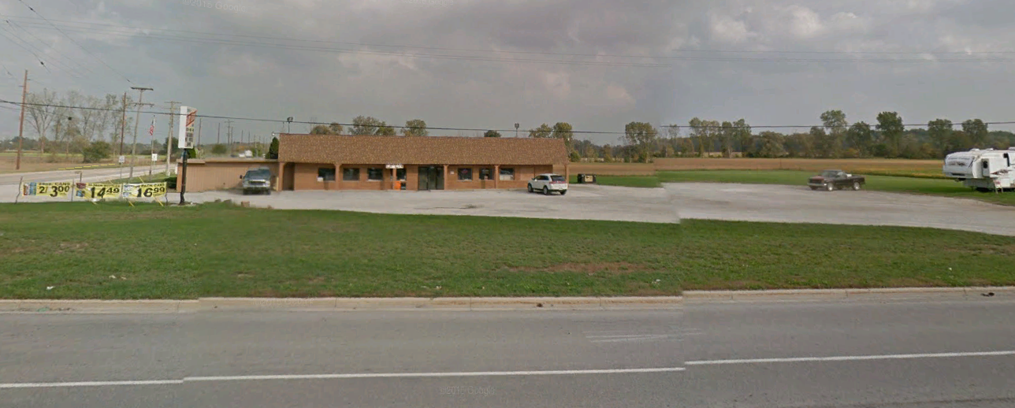

ANAYLSIS OF THE VARIANCE REQUEST:
The applicant is proposing to make various improvements to the site, including the construction of a 12’4” x 29’2” addition to the northeast corner of the building, and the installation of 8 gasoline pumps and a 62’ x 120’ gasoline canopy to the rear of the building.

In order to accomplish this, three (3) variances are required.

- Section 1300 of the Ray Township Zoning Ordinance requires that each lot within a B-2 zoning district shall have a minimum lot size of 90,000 square feet. The parcel’s total land area is 85,290 square feet. A variance is required to expand a structure on a non-conforming lot.

- Section 1300 requires a 110’ setback from the centerline of 32 Mile Road. The existing building, which is proposed to be enlarged, currently has a setback of 64’5”. A setback variance is required.

- Section 1300 and Section 2803 state that a building that is non-conforming relative to setbacks or height may be added to or enlarged if such addition or enlargement conforms to all regulations of the district in which it is located. The proposed addition would have a setback of 64’5” (similar to the existing building). A setback variance is required.

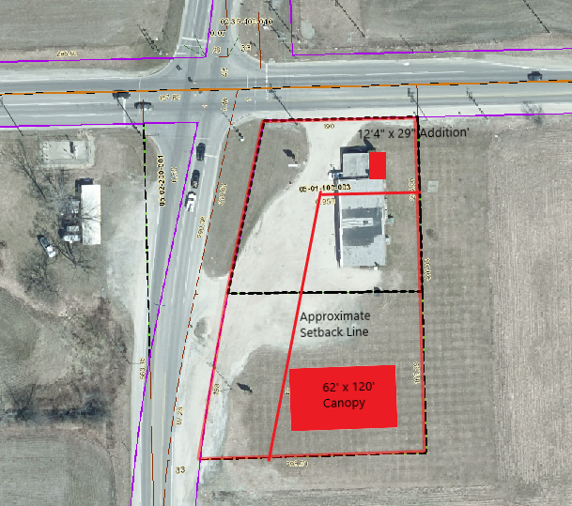

The photo above generally depicts the location of the proposed site improvements in relation to the required setback lines.

Road | Road Classification | Required Setback from centerline of Road | Proposed Setback | Setback Variance Required
32 Mile Road | Major Road | 110’ | 64’5” | 45’7”

AUTHORITY OF THE ZONING BOARD OF APPEALS:
Section 2706 of the Ray Township Zoning Ordinance specifies that variances may be granted if the Zoning Board of Appeals finds that:
- The strict enforcement of the Zoning Ordinance would cause practical difficulty and deprive the owner of rights enjoyed by all other property owners owning property within the same zoning district.
- The conditions and circumstances are unique to the subject property and are not similarly applicable to other properties in the same zoning district.
- The conditions and circumstances unique to the property were not created by the owner or his/her predecessors in title, within the time following the effective date of the provisions alleged to adversely affect such property.
- The requested variance will not confer special privileges that are denied other properties similarly situation and in the same zoning district.
- The requested variance will not be contrary to the spirit and interest of the Township Zoning Ordinance.

RECOMMENDATION:
In order to allow the proposed addition and improvements to the site, the following variances are required:
- A variance to allow construction on a lot having a total land area less than the required 90,000 square feet.
The existing conditions are unique to property, have not been self-created, and are not contrary to the spirit and interest of the Zoning Ordinance. I recommend approval of the variance request.
- A variance to allow the expansion of a non-conforming structure having a front yard setback less than 110 feet.
The property is oddly shaped, due to North Avenue being on a northeasterly diagonal, and is located on two major roads requiring extensive front yard setbacks. These conditions are unique to property, have not been self-created, and are not contrary to the spirit and interest of the Zoning Ordinance. I recommend approval of the variance request.
- A variance to allow an addition to the building with a front yard setback of 64’5”, which is 45’7” less than the required 110’.
The request to construct the addition within the front yard setback is self-created. There are no unique characteristics of the property that require the addition to be located at that precise location. Therefore, I recommend denial of the requested variance.
Chairman DeMan read the following correspondence into the record:
11-13-2018 Dennis LeMieux, Building Official, The variance request for 68970 North Avenue, I recommend approval for the minimum lot size variance request. For the request to vary minimum front yard setback, I recommend approval.
For the request to vary minimum front yard setback for an addition, I recommend denial. RE: There is plenty of area on the South side of the existing building to construct an addition.

11-13-2018 Kelly Timm, Assessor, RE: ZBA Variance Sunrise Stores, The Assessing Department has reveiwed
the request for the variances requested on the above referenced parcel. A variance is required to create a parcel with less than the minimum required 90,000 square feet and the minimum setback requirements. If approved, the applicant is required to submit an application to the Assessor to process the lot combination.
If you should have any questions regarding this information, please feel free to contact me.

Mr. Foster stated that the bathroom addition will square up the building and will not be any closer to the road than the existing building. They want to improve the corner and have visions of adding canopies and gas pumps on the South side of the building.
MOTION by Penzien support by Mathews to close public hearing at 7:42 P.M.
MOTION carried

Penzien asked if the existing building and the addition are in the Macomb County Road Commissions future right of way? Will the addition extend any farther than the existing structure?

DeMan stated it is in the townships required setback and the addtion will not extend past the existing North wall and will square up the building.

DeMan stated there are no existing bathrooms. By adding the ADA compliant bathrooms the building will become more compliant.

MOTION by Penzien supported by DeBuck to approve the request to vary Section 1300, B-2 General Business District Yard Dimension to allow the combination of two parcels with less than the required 90,000 square feet. Approve the request to vary Section 1300, B-2 to allow the expansion of a non-conforming structure having a front yard setback less than the required 110‘. Approve the request to vary Section 1300 to allow an addition to the building withing the front yard setback of 64‘5“ which is 45‘5“less than the required 110‘.
ROLL CALL VOTE:
Penzien – Yes
DeBuck – Yes
Youngblood – Yes
Mathews – Yes
DeMan – Yes
MOTION carried

5. Report from the Planning Commission Representative: Penzien stated the Planning Commission tabled a Special Land Use/Site Plan Approval for a Private Road until further information is received regarding a gas easement.
Planning commission also approved a site plan for a hangar addition at the Ray Community Airport. Pilots and families that have planes at the airport have a great passion for their hobby.

6. Public Comments: None

7. Adjournment
MOTION by DeBuck supported by Mathews to adjourn the meeting at 7:59 p.m.
MOTION carried.

Harold DeMan, Chairman Marvin DeBuck, Secretary Date

Respectfully submitted,
Lisa Hall, Recording Secretary
Township Clerk

