Location: Ray Township Hall
64255 Wolcott, Ray MI 48096

Present: Harold DeMan Jr., Chairman
Scott Mathews, Vice-Chairman
Marvin DeBuck, Secretary
Members: Tom Penzien
Betty Youngblood
Absent: None.

Also Present: Steve Cassin, Planning Consultant & Lisa Hall, Planning & Zoning Clerk
Attendance record on file.

- CALL TO ORDER- PLEDGE OF ALLEGIANCE AND ROLL CALL.
Chairman DeMan called the meeting to order at 7:00 p.m. The Pledge of Allegiance was recited.
All members were present.

- APPROVAL OF AGENDA
MOTION by Mathews supported by Youngblood to approve the agenda as presented.
MOTION carried.

- APPROVAL OF MINUTES: January 22, 2019
MOTION by Penzien supported by Youngblood to approve the meeting minutes of January 22, 2019 as presented.
MOTION carried.

- Scheduled Public Hearings-
Request to vary Section 402, Design Elements – Accessory Structure, Yard Dimensions, Minimum Front Yard Setback for 64665 Romeo Plank, Parcel 21-05-18-200-038, Brian Heitmann, Applicant.

Chairman DeMan explained the public hearing procedure, the planner would explain the variance request so the audience will be informed on the variance request. Then the public hearing would be open for the public to come to the podium, state their name and address and state any comments they may have regarding the variance request.

MOTION by Penzien supported by Youngblood to open the public hearing at 7:02 p.m.
MOTION carried.

Mr. Cassin, Planning Consultant presented his findings and recommendation dated January 13, 2019, they are as follows:
Applicant: Brian Heitmann
Location: 64665 Romeo Plank
Zoning District: R-1, Agricultural Residential
Property ID: 21-05-18-200-038 (Case No. PZBA-19-002)
Size of Parcel: 5.0 acres of land
Action Requested: Request variance to allow accessory structure in the front yard

PROPERTY CHARACTERISTICS

The property, located on the west side of Romeo Plank Road and north of 30 Mile Road, is currently zoned R-1, Agricultural Residential. It is developed with a single-family house and two accessory structures (one which is proposed to be removed). The home is set back approximately 630 feet from the centerline of Romeo Plank Road.

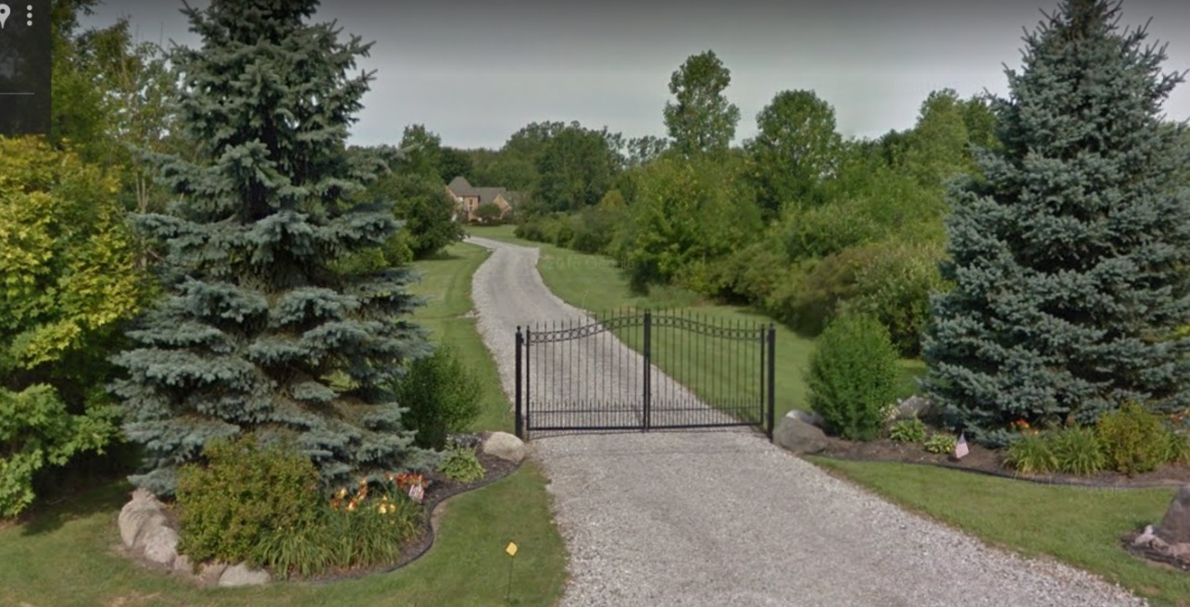

ANALYSIS OF VARIANCE REQUEST

The applicant is proposing to relocate a small shed/out building and construct a 1,500 square foot pole barn in the front yard. Section 402 of the Ray Township Zoning Ordinance does not allow accessory structures within the front yard. However, the applicant is requesting a variance due to the unique characteristics of the property, being the locations of an existing well and septic field, which prohibits access to the rear of the property for any possible construction.

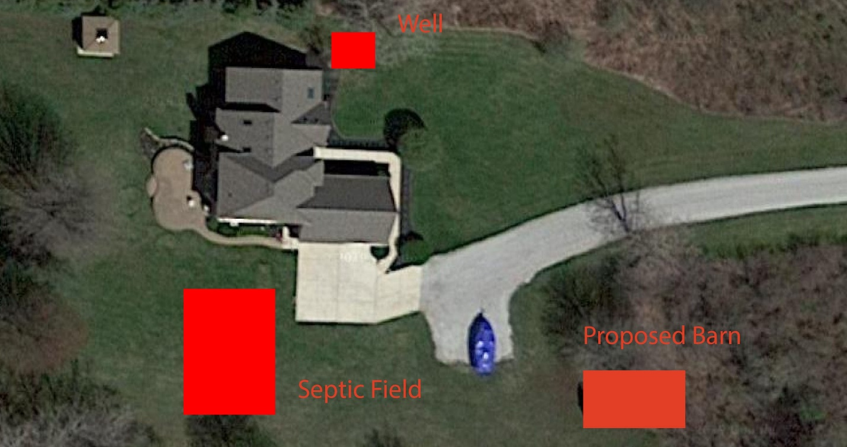

The photo above generally depicts the proposed location of the barn, along with existing property characteristic.

AUTHORITY OF THE ZONING BOARD OF APPEALS

Section 2706 of the Ray Township Zoning Ordinance specifies that variances may be granted if the Zoning Board of Appeals finds that:
- The strict enforcement of the Zoning Ordinance would cause practical difficulty and deprive the owner of rights enjoyed by all other property owners owning property within the same zoning district.
- The conditions and circumstances are unique to the subject property and are not similarly applicable to other properties in the same zoning district.
- The conditions and circumstances unique to the property were not created by the owner or his/her predecessors in title, within the time following the effective date of the provisions alleged to adversely affect such property.
- The requested variance will not confer special privileges that are denied other properties similarly situation and in the same zoning district.
- The requested variance will not be contrary to the spirit and interest of the Township Zoning Ordinance.

RECOMMENDATION

The requested variance is based upon conditions which are unique to property and have not been self-created. Granting the variance would not be contrary to the spirit and intent of the Zoning Ordinance. Furthermore, the natural characteristics of the site (wooded area) would limit visibility of the pole barn from the road. Therefore, I recommend approval of the variance.

DeMan asked Mr. Heitmann if he had any comments?
Heitmann stated he had no questions or comments.
Chairman read correspondence as follows:
3-18-19 Dennis LeMieux, Building Official advised the building department has no issues with placing the accessory building in the front yard.
3-21-19 Kelly Timm, Township Assessor, regarding ZBA Variance 05-18-200-038, The assessing department has reviewed the request for the variance requested on the above referenced parcel. I do not have any comments for review of this application. If you should have any questions regarding this information, please feel free to contact me.
MOTION by Penzien supported by Mathews to close the public hearing at 7:04 p.m.
MOTION carried.

Penzien stated he has no problem

DeBuck stated the house was built in 1995 and the neighbor to the North has an accessory building constructed in front of the house.

Penzien stated this is a Ray Township Ordinance that does not allow accessory buildings in front of the home. Why is this an ordinance.

DeBuck stated it is an ordinance because it is not common to have an accessory building in front of the home, most homes are built near the road.

Penzien asked if the ordinance is to give the township a uniform appearance?

DeMan stated it is a unique situation, most don’t want to see the accessory building first.

DeBuck stated the applicant did not create the need to put the barn in front of the home and you will not see the barn because of the trees.

MOTION by Penzien supported by Youngblood to approve the request to vary Section 402, Design Elements, Accessory Structure, Yard Dimensions, Minimum Front Yard Setback of the Ray Township Zoning Ordinance an allow the construction of a one thousand five hundred (1,500) square foot accessory building located within the front yard and in front of the primary residence.
MOTION carried.

DeBuck asked Mr. Heitmann if he would be moving the shed that is in currently located in the front yard?

Heitman advised yes, he would be re-locating it.

5.
A. Election of Officers
MOTION by Penzien supported by Youngblood for current officers to remain in place for 2019.
DeMan, Chairman, Mathews, Vice-Chairman, DeBuck, Secretary.
MOTION carried.

B. Amend ZBA By-Laws
DeMan stated the by-law amendment is to correct the meeting time, from 7:30 P.M. to 7:00 P.M.
MOTION by Mathews supported by Penzien to amend the by-laws as presented.
MOTION carried.

6. Report from the Planning Commission representative
The planning commission had to recommend denial of a rezoning request from R-1 to Industrial on the East Side of North Avenue South of 27 Mile Road based on the Ray Township Master Plan. The property was previously zoned I-R, when the Master Plan was reviewed in 2015/2016, the parcels on the East side of North Avenue between 26 Mile Road and 27 Mile Road were rezoned back to R-1after much discussion by the Planning Commission, Ray Township Board, Mr. Dailey and Mr. Schmeiser, Planning Consultants. The property making the request for rezoning was notified of the proposed Master Plan amendment. The Planning Commission sent the recommendation to the Township Board of Trustees. The applicant may take the matter further.

7. Public Comments: None.

8. Adjournment
MOTION by DeBuck supported by Mathews to adjourn the meeting at 7:13 p.m.
MOTION carried.

Harold DeMan, Chairman Marvin DeBuck, Secretary Date

Respectfully submitted,
Lisa Hall, Recording Secretary

