Location: Ray Township Hall
64255 Wolcott, Ray MI 48096

Present: Scott Mathews, Vice-Chairman
Marvin DeBuck, Secretary
Members: Tom Penzien
Members: Betty Youngblood

Absent: Harold DeMan Jr., Chairman - Excused

Also Present: Steve Cassin, Planning Consultant & Lisa Hall, Planning & Zoning Clerk
Attendance record on file.

- CALL TO ORDER- PLEDGE OF ALLEGIANCE AND ROLL CALL.
Vice-Chairman Mathews called the meeting to order at 7:00 p.m. The Pledge of Allegiance was recited.
A quorum of the board was present.

- APPROVAL OF AGENDA
MOTION by Penzien supported by Youngblood to approve the agenda as presented.
MOTION carried.

- APPROVAL OF MINUTES: May 28, 2019
MOTION by DeBuck supported by Youngblood to approve the meeting minutes of May 28, 2019 as presented.
MOTION carried.

- Scheduled Public Hearings-
1. Request to vary Section 400, Design Elements – Principal Structure, Yard Dimensions, Minimum Front Yard Setback. 58925 North Avenue, Parcel ID 21-05-36-100-027, Patricia Miller, Applicant.

Vice Chairman Mathews explained the public hearing procedure, the planner will explain the variance request so the audience will be informed on the variance request. Then the public hearing would be open for the public to come to the podium, state their name and address and state any comments they may have regarding the variance request.

MOTION by Penzien supported by Youngblood to open the public hearing at 7:01 p.m.
MOTION carried.

Mr. Cassin, Planning Consultant presented his findings and recommendation dated May 28,2019 they are as follows:
GENERAL INFORMATION

Applicant: Carl & Patricia Miller
Location: 58925 North Avenue (southwest corner of 27 Mile Road and North Ave.
Zoning District: R-1, Agricultural Residential
Property ID: 21-05-36-100-027 (Case No. PZBA-19-008)
Size of Parcel: 5.83 acres of land
Action Requested: Request variance of the required front yard setback off North AvenueALYSIS77
PROPERTY CHARACTERISTICS

The property, located at the southwest corner of 27 Mile Road and North Avenue, is currently zoned R-1, and is developed with a single-family house and several outbuildings. The house fronts North Avenue, and is setback approximately 70 feet from the centerline of the road. The house is considered a non-conforming structure since it does not meet the required zoning ordinance front yard setback requirements.

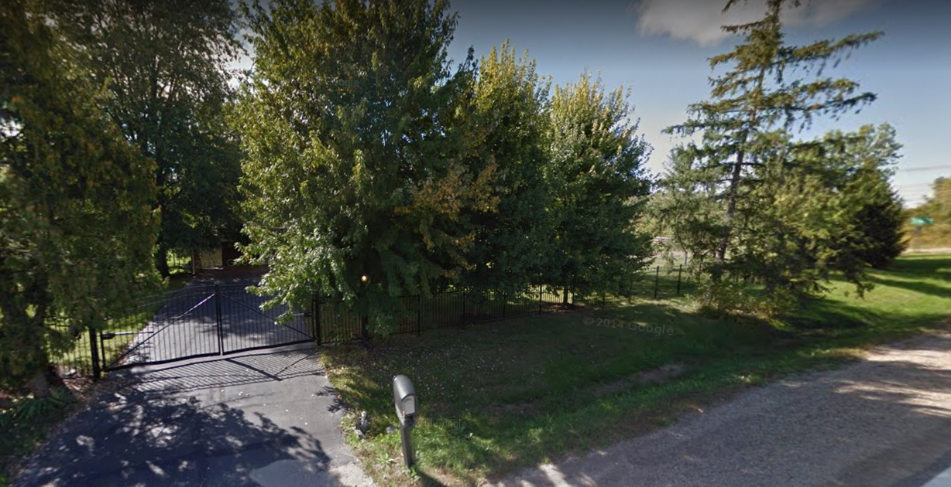
Elevation view of subject property looking west from North Ave.

ANALYSIS OF VARIANCE REQUEST

The applicant is proposing to divide the existing 5.83-acre parcel into 2 different parcels, one containing 2.22 acres and the other containing 3.61 acres. Section 6.00-E-1 of the Ray Township Land Division Ordinance states that no division of land shall be approved by the Township Assessor unless all township ordinance requirements, including zoning ordinance provisions, are complied with.

Section 1300 of the Ray Township Zoning Ordinance requires a 110’ setback from the centerline of North Avenue. The existing dwelling on Parcel B, which is proposed to remain, has a front yard setback from North Ave. of approximately 70 feet. Therefore, a setback variance of 40’ is required.

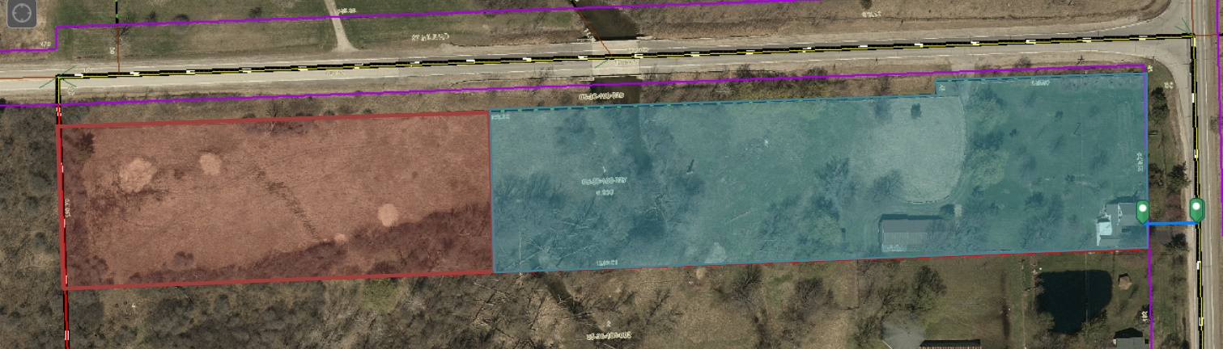
Parcel B – 3.61 Acres
Parcel A – 2.22 Acres
Approximately 70-foot setback from centerline of road.
The photo above generally depicts the proposed parcel split.

Road | Road Classification | Required Setback from centerline of Road | Existing Setback | Setback Variance Required
North Avenue | Major Road | 110’ | 70’ | 40’

AUTHORITY OF THE ZONING BOARD OF APPEALS

Section 2706 of the Ray Township Zoning Ordinance specifies that variances may be granted if the Zoning Board of Appeals finds that:
- The strict enforcement of the Zoning Ordinance would cause practical difficulty and deprive the owner of rights enjoyed by all other property owners owning property within the same zoning district.
- The conditions and circumstances are unique to the subject property and are not similarly applicable to other properties in the same zoning district.
- The conditions and circumstances unique to the property were not created by the owner or his/her predecessors in title, within the time following the effective date of the provisions alleged to adversely affect such property.
- The requested variance will not confer special privileges that are denied other properties similarly situation and in the same zoning district.
- The requested variance will not be contrary to the spirit and interest of the Township Zoning Ordinance.

RECOMMENDATION

The existing conditions are unique to property, have not been self-created, and is not contrary to the spirit and intent of the Zoning Ordinance. I recommend approval of the variance request.
MOTION by Penzien supported by DeBuck to close the public hearing at 7:04p.m.
MOTION carried.

Penzien asked Cassin if the required front yard setback is 110‘ from the center of the road and if a new single family home will fit on the newly created parcel if split is approved?

Cassin advised the required front yard setback is 110‘.

Penzien asked what the small jog shown on the survey is from.

Mrs. Miller advised when the bridge was put in on 27 Mile road they requested the Department of Roads leave the trees on the North property line, creating the need to leave the small strip/jog at the North-East section of the parcel along 27 Mile.

Mathews asked if anyone had any further comments or discussion?

MOTION by Penzien supported by DeBuck to approve the request to vary Section 400, Yard Dimensions, Minimum Front Yard Setback, existing home located with minimum front yard setback at 58925 North Avenue, Parcel ID 21-05-36-100-027.
FOR THIS MOTION: YES: Penzien, DeBuck, Youngblood, Mathews
NO: None
MOTION carried

5. Old Business:
Tabled from May 28, 2019 Meeting, Request to Vary Section 2002, B-2 Business Zoning Districts, 2, (c). Section 2003 Specific Regulations, 3, (d). Section 2003, 7, Monument or ground signs (a), 1 and 7, (c). Section 2004 General regulations, section 2004, 1, (e). 68970 North Avenue, Parcel 21-05-01-100-005, Sunrise Stores, L.L.C., Dave Foster, Applicant

Mr. Cassin provided a verbal report:

Cassin stated the Zoning Board of Appeals tabled the application request to vary Section 2002, B-2 Business Zoning Districts, 2, (c). Section 2003 Specific Regulations, 3, (d). Section 2003, 7, Monument or ground signs (a), 1 and 7, (c). Section 2004 General regulations, section 2004, 1, (e). 68970 North Avenue, Parcel 21-05-01-100-005Sunrise Stores, L.L.C, Dave Foster at the May 28, 2019 meeting.

Cassin stated the ZBA board requested the Fosters set up a meeting with Ray Township Planning and Zoning to discuss height and size of existing similar signs, have drawings revised and submit new proposal to ZBA board at the June 4, 2019 Special ZBA meeting.

On May 30, 2019, Dave Foster met with Lisa and I at the office to review similar signs in the area. The Mobil Express sign located at the SE corner of 32 Mile and Romeo Plank in Ray Township was reviewed and a comparison was made of the sign at SE corner of 26 Mile and Romeo Plank in Macomb Township.
The existing sign at 32 Mile and Romeo Plank is twenty (20) foot tall and ten (10) feet wide at the top. Square footage on each side is approximately 130 sq. ft per side.

Foster has submitted revised sign drawings consistent with other gas/convenience store signs in the area.

Cassin advised he has no objections to the new signs as submitted on 6-3-19.

DeBuck asked if the two (2) signs, one (1) on 32 Mile Road and one (1) on North Avenue will be the same size?
Penzien stated two (2) signs are what the applicant has requested.

DeBuck asked if the size of the signs is adequate due to the uniqueness of the parcel.

Foster advised the original sign request showed pricing for regular and plus grade gas and for diesel fuel. They cut out pricing for one product to make the size of the signs meet the requirements

MOTION by Penzien supported by DeBuck to approve the variances to all sections of the ordinances as follows: Approve the request to vary Section 2002, B-2 Business Zoning Districts, 2, (c) allow two (2) signs. Approve the request to vary Section 2003 Specific Regulations, 3, (d) exceed sixteen (16) square feet of digital sign area. Approve the request to vary Section 2003, 7, Monument or ground signs (a), 1, exceed permitted square footage of sign area and 7, (c) exceed six (6) feet in height and (d) exceed square footage of permitted sign area at the intersection of two (2) major thoroughfares on two (2) signs. Approve the request to vary Section 2004 General regulations, Section 2004, 1, (e) allow two (2) signs to encroach into the required front yard setback at 68970 North Avenue, Parcel 21-05-01-100-005, Sunrise Stores, L.L.C., Dave Foster, Applicant

6. Report from the Planning Commission Representative: Planning Commission meeting scheduled for June 11, 2019

7. Public Comments: None

8. Adjournment
MOTION by DeBuck supported by Youngblood to adjourn the meeting at 7:14p.m.
MOTION carried.

Harold DeMan, Chairman Marvin DeBuck, Secretary Date

Respectfully submitted,
Lisa Hall, Recording Secretary

