Location: Ray Township Hall
64255 Wolcott, Ray MI 48096

Present: Harold DeMan Jr., Chairman – arrived at 7:23 P.M.
Scott Mathews, Vice-Chairman
Marvin DeBuck, Secretary
Members: Tom Penzien
Betty Youngblood
Absent: None

Also Present: Steve Cassin, Planning Consultant & Lisa Hall, Planning & Zoning Clerk
Attendance record on file.

- CALL TO ORDER- PLEDGE OF ALLEGIANCE AND ROLL CALL.
Vice -Chairman Mathews called the meeting to order at 7:00 p.m. The Pledge of Allegiance was recited.
All members were present.

- APPROVAL OF AGENDA
MOTION by Youngblood supported by DeBuck to approve the agenda as presented.
MOTION carried.

- APPROVAL OF MINUTES: April 23, 2019
MOTION by Penzien supported by Youngblood to approve the meeting minutes of April 23, 2019 as presented.
MOTION carried.

- Scheduled Public Hearings-
1. Request to vary Section 200, Accessory Buildings in Residential Districts, C, Maximum Size Limits. Vary Section 400, Design Elements – Principal Structure, Yard Dimensions, Minimum Front Yard Setback. Vary Section 400, Lot Dimensions, Minimum Width to Depth Ratio for Hayes, Parcels 21-05-30-300-014 and 21-05-30-300-028, Janet VanHoutte and Eileen D’Hondt, Applicants.

Vice Chairman Mathews explained the public hearing procedure, the planner would explain the variance request so the audience will be informed on the variance request. Then the public hearing would be open for the public to come to the podium, state their name and address and state any comments they may have regarding the variance request.

MOTION by Penzien supported by Youngblood to open the public hearing at 7:02 p.m.
MOTION carried.

Mr. Cassin, Planning Consultant presented his findings and recommendation dated May 19,2019 they are as follows:
GENERAL INFORMATION

Applicant: Donald & Janet VanHoutte, Eileen D’Hondt
Location: 59480 & 59520 Hayes (east side of Hayes, north of 27 Mile Road)
Zoning District: R-1, Agricultural Residential
Property ID: 21-05-30-300-014, 21-05-30-300-028
Size of Parcel: 67.8 acres
Action Requested: Request variance of lot width to depth ratio, accessory building size, and front yard setback.
ANALYSIS
PROPERTY CHARACTERISTICS

The property is located on the east side of Hayes Road, north of 27 Mile Road. Parcels A, B, and C are primarily vacant, and Parcel D is developed with a home, barn, and other accessory buildings.

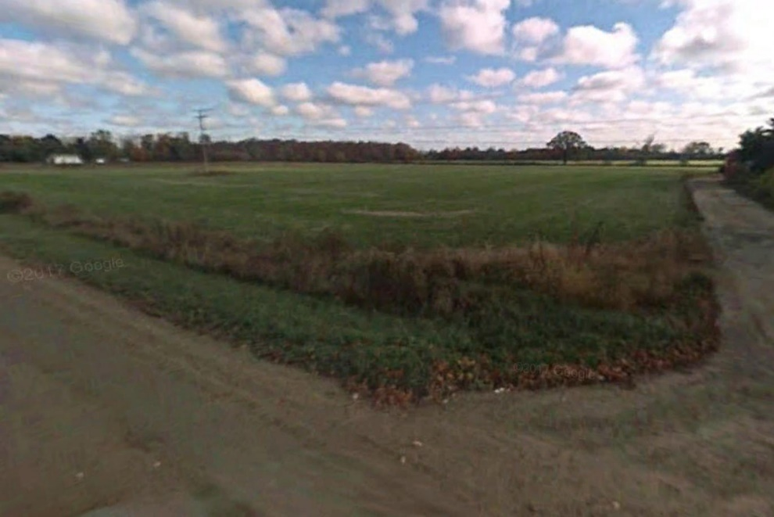

View of Parcels A, B, & C from Hayes Road
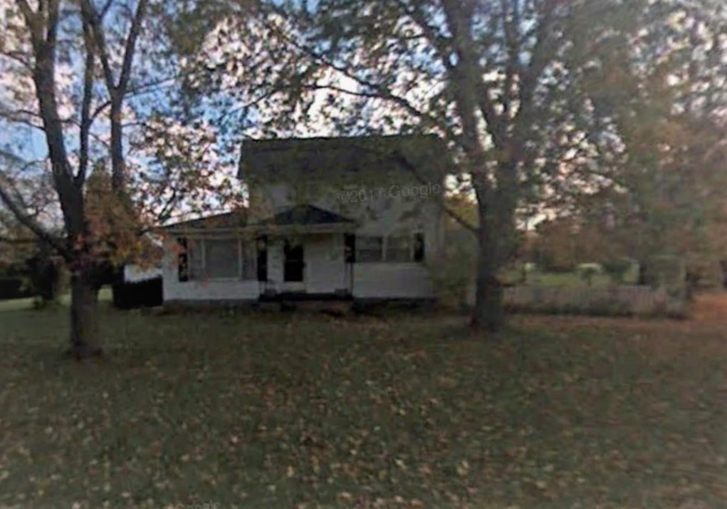

View of Parcel D from Hayes Road

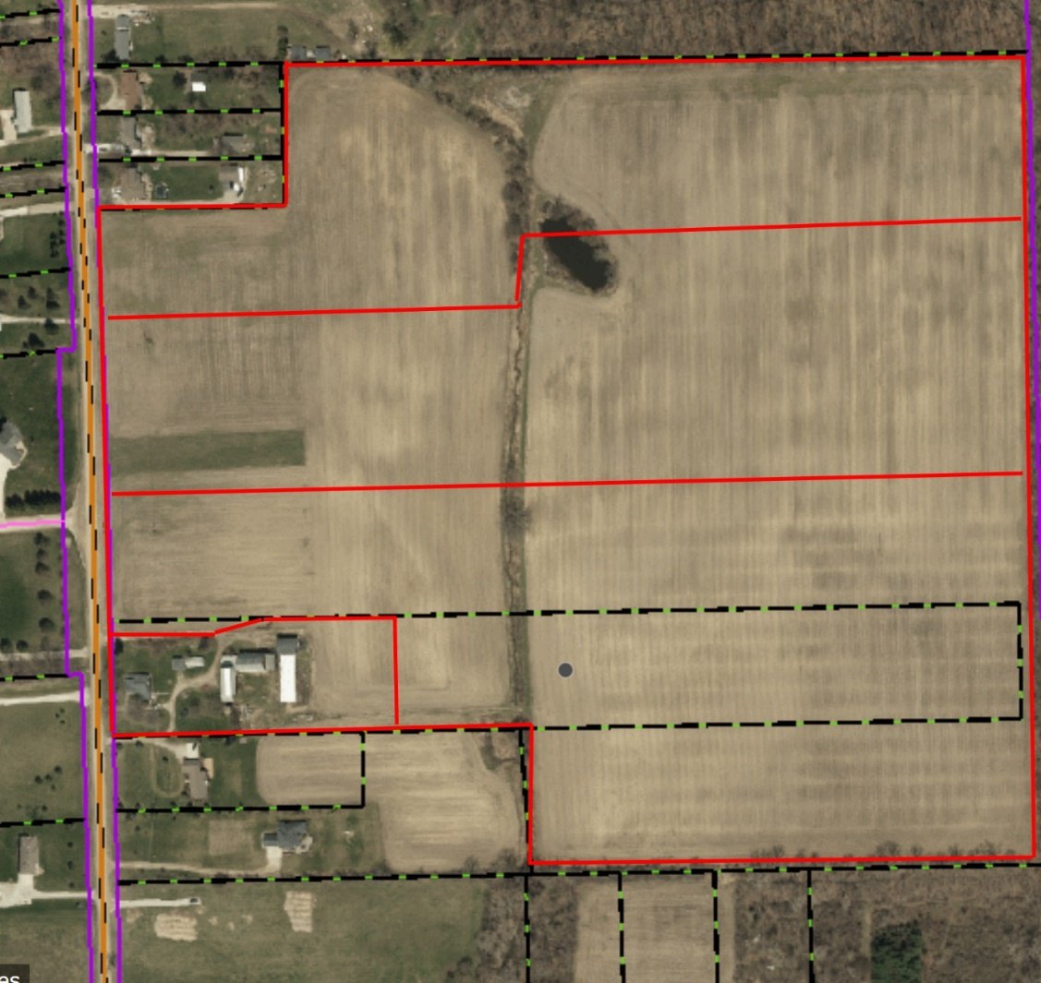
Parcel A
Parcel C
Parcel B
Parcel D
Hayes Road

Proposed property split into 4 parcels
ANALYSIS OF VARIANCE REQUEST

The applicant is proposing splitting the land into 4 separate parcels. Section 6.00-E-1 of the Ray Township Land Division Ordinance states that no division of land shall be approved by the Township Assessor unless all township ordinance requirements, including zoning ordinance provisions, are met.

In this regard, several variances are necessary as indicated below:

Parcel A - Section 400 of the Ray Township Zoning Ordinance specifies a maximum 1:4 width to depth ratio for parcels within the R-1 zoning district. This parcel would have a width of 262.96 feet and a depth of 2009.94 feet (1:7.6 width to depth ratio).

Parcel B – The parcel would have a width of 404.85 feet and a depth of 2021.86 feet (1:4.99 width to depth ratio).

Parcel C – The parcel would have a width of 273.40 feet and a depth of 2023.42 feet (1:4.99 width to depth ratio).

Parcel D – Section 400 of the Ray Township Zoning Ordinance requires a minimum front yard setback of 110 feet from the center line of the road. The existing home is setback approximately 63 feet from the center line of the road.

Parcel D – Section 200 of the Ray Township Zoning Ordinance limits the size of accessory buildings (on properties between 3 – 3.49 acres) to a total of 2,400 square feet. Although one of the barns may be demolished, at the present time the total square footage of the existing accessory structures is approximately 7,172 square feet.

AUTHORITY OF THE ZONING BOARD OF APPEALS

Section 2706 of the Ray Township Zoning Ordinance specifies that variances may be granted if the Zoning Board of Appeals finds that:
- The strict enforcement of the Zoning Ordinance would cause practical difficulty and deprive the owner of rights enjoyed by all other property owners owning property within the same zoning district.
- The conditions and circumstances are unique to the subject property and are not similarly applicable to other properties in the same zoning district.
- The conditions and circumstances unique to the property were not created by the owner or his/her predecessors in title, within the time following the effective date of the provisions alleged to adversely affect such property.
- The requested variance will not confer special privileges that are denied other properties similarly situation and in the same zoning district.
- The requested variance will not be contrary to the spirit and interest of the Township Zoning Ordinance.

RECOMMENDATION

The existing conditions are unique to property, have not been self-created, and are not contrary to the spirit and intent of the Zoning Ordinance. I recommend approval of the 5 variance requests.
Mathews read correspondence as follows:

5-14-2019 Kelly Timm, Ray Township Assessor, the assessing department has reviewed the request for the variances requested on the above referenced parcel.
A variance is required to create Parcels A, B, C and D. Three parcels exceed the 4;1 Depth to width Ratio as outlined in the Ray Township Zoning Ordinance.

If approved the applicant is required to submit an application to the Assessor to process the split.

If you should have any questions regarding this information, please feel free to contact me.

5-21-2019 Dennis LeMieux, Building Official advised the building department has no objections to the variance requests at 59480 Hayes and 59520 Hayes.

Mathews asked the applicant if he had any comment?

Tom Hancock speaking for the applicants stated the splits are primarily for estate planning purposes. Five (5) revisions have been made to the survey to the satisfaction of the Ray Township Assessor and Ray Township Zoning Department.
The existing home was built in the mid 1800’s and is in excellent condition. One of the barns has fallen, all but two of the other accessory buildings will be torn down, leaving approximately 3575 square feet of accessory buildings. No commercial activity will be conducted in the barns.

DeBuck asked which buildings will remain and if the applicant knows that if the house is ever removed or destroyed any new structure would have to meet the required front yard setback of 110’?

Hancock stated the detached garage and the original rhubarb house are the buildings that will remain.

Mathews asked the board if anyone had any questions for the applicant?

MOTION by Penzien supported by Youngblood to close the public hearing at 7:11 p.m.
MOTION carried.

Penzien questioned why Ray Townships has the 4:1 Depth to Width Ratio and is it something that needs to be looked at?

DeBuck stated there are many farms in the Township that are ¼ to ½ mile in depth.

MOTION by Penzien supported by Youngblood to approve the request to vary Section 200, Accessory Buildings in Residential Districts, C, Maximum Size Limits. Approve the request to vary Section 400, Design Elements – Principal Structure, Yard Dimensions, Minimum Front Yard Setback at 59520 Hayes, Parcel 21-05-30-300-014. Approve three (3) requests to vary Section 400, Lot Dimensions, Minimum Width to Depth Ratio creating three new parcels for 21-05-30-300-028, Janet VanHoutte and Eileen D’Hondt, Applicants.
FOR THIS MOTION: YES: Penzien, Youngblood, DeBuck, Mathews,
NO: None
MOTION carried.

Scheduled Public Hearings-
2. Request to Vary Section 1300, B-2 General Business District, Yard Dimensions, Minimum Front-yard Setback Requirement. Request to Vary Section 2002, B-2 Business Zoning Districts, 2, (c). Section 2003 Specific Regulations, 3, (d). Section 2003, 7, Monument or ground signs (a), 1 and 7, (c). Section 2004 General regulations, section 2004, 1, (e). 68970 North Avenue, Parcel 21-05-01-100-005, Sunrise Stores, L.L.C., Dave Foster, Applicant.

Vice Chairman Mathews explained the public hearing procedure, the planner would explain the variance request so the audience will be informed on the variance request. Then the public hearing would be open for the public to come to the podium, state their name and address and state any comments they may have regarding the variance request.

MOTION by Penzien supported by DeBuck to open the public hearing at 7:17p.m.
MOTION carried.

Mr. Cassin, Planning Consultant presented his findings and recommendation dated May 19,2019 they are as follows:

GENERAL INFORMATION

Applicant: Dave Foster, Sunrise Stores
Location: 68970 North Avenue (southeast corner of North Ave. and 32 Mile Road)
Zoning District: B-2 General Business
Property ID: 21-05-01-100-005
Size of Parcel: 1.958 acres of land (85,290 square feet)
Action Requested: Variances relative to number and size of signs, and encroachments into the front yard setbacks.
ANALYSIS
PROPERTY CHARACTERISTICS

The property is located at the southeast corner of North Avenue and 32 Mile Road, is currently zoned B-2 General Business, and is developed with a convenience store. The building is considered a non-conforming structure because it encroaches into the required front yard setback from 32 Mile. The property is also considered non-conforming because a minimum lot size of 90,000 square feet is required in the B-2 district.

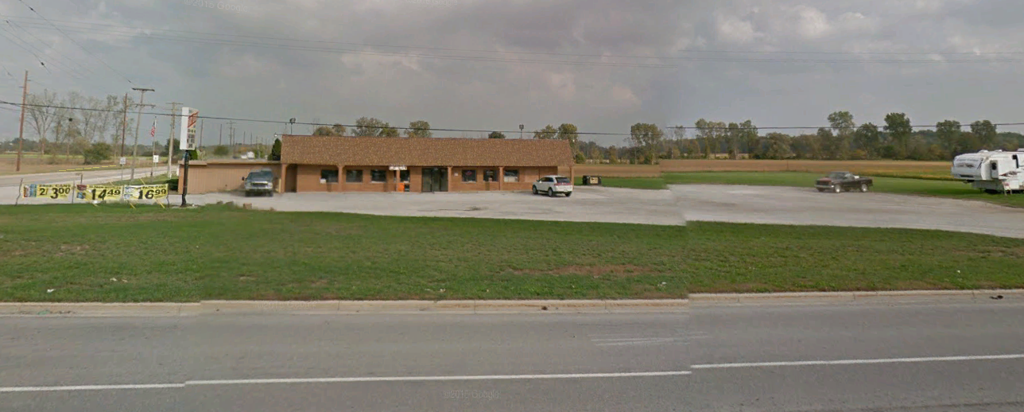
ANALYSIS OF VARIANCE REQUEST

The applicant is proposing to make various improvements to the site, including the installation of 11 gasoline pump islands and a 62’ x 196’ gasoline canopy south of the existing building. In addition, two signs having a height of 27’ 10” and an area of 204 square feet are proposed (one along 32 Mile Road and the other along North Avenue).

Section 1300 of the Ray Township Zoning Ordinance requires a 110’ setback from the centerline of both North Avenue and 32 Mile Road.

The site plan as submitted proposes several improvements within these required setbacks, including gas pumps, gas pump canopy, lighting, septic field, off-street parking, maneuvering lanes, and a water tank.

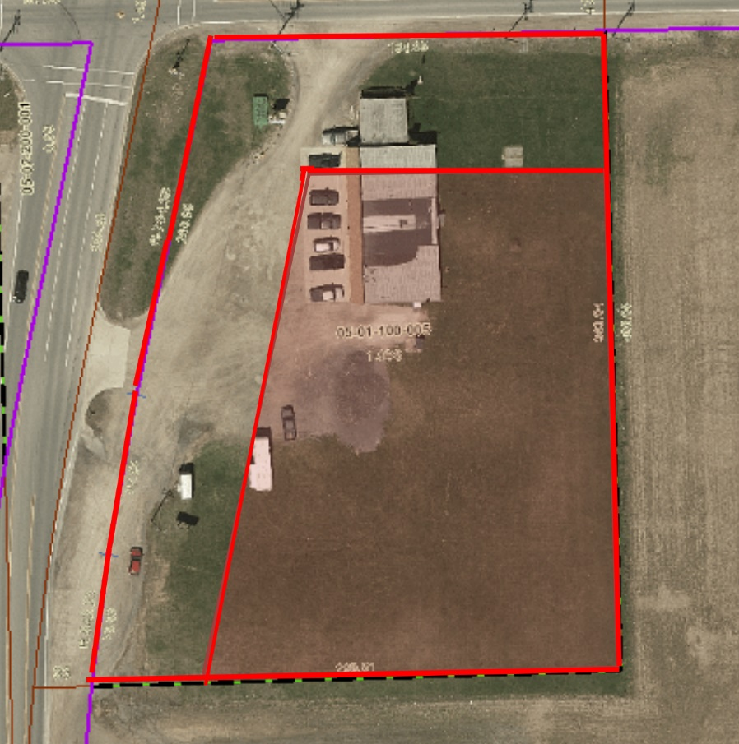
Shaded area indicates buildable area behind setbacks

Section 2003 of the Ray Township Zoning Ordinance specifies that in the B-2 Zoning District, one monument sign having a maximum area of 64 square feet and a maximum height of 6 feet is allowed. Furthermore, in the instance of property having frontage on two major thoroughfares, an additional monument sign is allowed, provided that the maximum square footage is split between the two signs.

The applicant is proposing two monument signs, each having an area of 204 square feet and a height of 27’ 10”.

AUTHORITY OF THE ZONING BOARD OF APPEALS

Section 2706 of the Ray Township Zoning Ordinance specifies that variances may be granted if the Zoning Board of Appeals finds that:
- The strict enforcement of the Zoning Ordinance would cause practical difficulty and deprive the owner of rights enjoyed by all other property owners owning property within the same zoning district.
- The conditions and circumstances are unique to the subject property and are not similarly applicable to other properties in the same district.
- The conditions and circumstances unique to the property were not created by the owner or his/her predecessors in title, within the time following the effective date of the provisions alleged to adversely affect such property.
- The requested variance will not confer special privileges that are denied other properties similarly situation and in the same zoning district.
- The requested variance will not be contrary to the spirit and interest of the Township Zoning Ordinance.

RECOMMENDATION

In order to allow the proposed improvements to the site, the following variances are required:
- A variance to allow construction of several site improvements within the front yard setback.
The property is oddly shaped, due to North Avenue being on a northeasterly diagonal, and is located on two major roads requiring extensive front yard setbacks. These conditions are unique to property, have not been self-created, and are not contrary to the spirit and interest of the Zoning Ordinance. I recommend approval of the variance request.
- A variance to allow 2 signs having a height of 27’10”, which is 21’10” higher than that allowed.

The sign variance request is excessive, not in character with the surrounding area, and is self-created. Furthermore, there are no unique characteristics of the property that would necessitate a sign of having a height of nearly 28 feet. Therefore, I recommend denial of the requested variance.

- A variance to allow 2 signs having a combined area of 408 square feet, which is 344 square feet in excessive of that allowed.

The sign variance request is excessive, not in character with the surrounding area, and is self-created. Furthermore, there are no unique characteristics of the property that would necessitate the variance. Therefore, I recommend denial of the requested variance.

Mathews read correspondence as follows:

5-21-2019 Dennis LeMieux, Building Official advised the building department has the following comments:
1. A variance to allow construction of several site improvements within the front yard setbacks. The building department recommends approval.
2. A variance to allow 2 signs 27’10”. The building department recommends denial.
Mathews asked the applicant if he had any comments?
Tom Foster stated the curve on North Avenue and the speeds traveled will make signage difficult to see if the signs are not tall enough from all directions.
MOTION by Penzien supported by DeBuck to close the public hearing at 7:24p.m.
MOTION carried.

DeBuck stated if board approves the variance it will set a precedence for larger signs in the commercial districts.

Penzien stated he agrees with DeBuck but also with the applicant. Would like to see info on size of sign at 32 Mile and Romeo Plank Mobil Express.

Youngblood stated North Avenue and 32 Mile road is an unsafe intersection due to the curve and the speeds traveled. Would rather have the sign be visible to drivers, not have to strain to see.

Penzien asked Younblood if she was referring to the sign height or overall size?

Youngblood stated we do not have many gas stations in Ray Township and would like to be able to see and read the sign and price from a distance.

Penzien stated the applicant’s request is too large and the ordinance requirements are to small. Does the ZBA have the authority to negotiate?

Cassin stated that signs on Hall Road and Gratiot have height limits of 15‘ to 18‘ with 6‘ feet of clearance from the ground and 120 square feet of sign area per side.

Mathews questioned if the board could make the stipulations work that Cassin suggested?

Penzien asked Cassin if he would look at the sign ordinance and the other comparibale sites and signs in the township?

Foster asked if Marathon can go on the canopy?

Cassin advised yes but there are size limits.

Penzien stated board should do homework and return with thoughts to the next meeting on June 4, 2019.

MOTION by Penzien supported by DeBuck to approve the request to vary Section 1300, B-2 General Business District, Yard Dimensions, Minimum Front-yard Setback requirement to allow construction of a gas canopy, and installation of the following: gas pumps water holding tank, septic field, off street parking, maneuvering lanes, two (2) signs and lighting within the required front yard setback.
Table request to vary Section 2002, B-2 Business Zoning Districts, 2, (c). Section 2003 Specific regulations, 3, (d). Section 2003, 7, Monument or ground signs (a), 1 and 7, (c) & (d). Section 2004, 1, (e). to Tuesday June 4, 2019 Special ZBA meeting.
FOR THIS MOTION: YES: Penzien, DeBuck, Youngblood, Mathews, DeMan
NO: None
MOTION carried

5. Report from the Planning Commission Representative: None

6. Public Comments: None

7. Adjournment
MOTION by Penzien supported by DeBuck to adjourn the meeting at 8:01p.m.
MOTION carried.

Harold DeMan, Chairman Marvin DeBuck, Secretary Date

Respectfully submitted,
Lisa Hall, Recording Secretary

