Location: Ray Township Hall
64255 Wolcott. Ray, MI 48096

Present: Tom Penzien, Chairman
Justin Lease, Vice-Chair
Randy Forro, Secretary
Members: Sharilyn Kaniuk
Justin Marberg
Doug Stier
John Zoccola
Absent:

Also Present: Lisa Hall, Planning and Zoning Clerk,
Stephen Cassin, Township Planner.
Attendance record on file

1.CALL TO ORDER – PLEDGE OF ALLEGIANCE AND ROLL CALL.
Chairman Penzien called the meeting to order at 7:00 p.m. The Pledge of Allegiance was recited. Penzien, Marberg, Lease, Forro, Kaniuk, Stier and Zoccola, all members were present.

2.APPROVAL OF MINUTES – April 9, 2019, amended.
MOTION by Stier supported by Forro to approve the April 9, 2019 minutes as presented.
MOTION carried.

3.APPROVAL OF AGENDA-
MOTION by Stier supported by Zoccola to approve the agenda as presented.
MOTION carried.

4. SCHEDULED PUBLIC HEARINGS
A. Special Land Use application, asphalt office and yard, outdoor storage of contractor’s equipment and materials. 16077 31 Mile Road, Parcel ID 21-05-06-401-003, JRO Properties Management, LLC. Applicant

Chairman Penzien explained the public hearing procedure to the residents that the Planner will present his findings for the application. The correspondences from the departments would be read into the record. Then the public should come to the podium, state their name, address and any concerns or comments they have on the item.

MOTION by Kaniuk supported by Forro to open the public hearing at 7:02 P.M.
MOTION carried.

Mr. Cassin, Planning Consultant presented his findings and recommendation dated June 3,2019 as follows:

GENERAL INFORMATION
ERAL INFORMATIO INFORMATION
Zoning: I-1, Industrial
Location: North of 31 Mile Road, west of Romeo Plank
Property ID #: 21-05-06-401-005
Project Name: JRO Properties – Total Asphalt Office and Storage Yard
Case No: PSLU-19-001
Applicant: Orchard Construction
Review Date: June 3, 2019

PROPERTY CHARACTERISTICS
The applicant desires to construct a 5,920 square foot (80’ x 74’) industrial “shop” building, along with a 1,512 square foot (42’ x 36’) on 22.01 acres on land zoned I-1 Industrial, located on the north side of 31 Mile Road, west of Brian Drive. In addition, the applicant is proposing outside storage of contractor’s equipment and supplies.
The property is currently developed with a single-family home and several outbuildings.
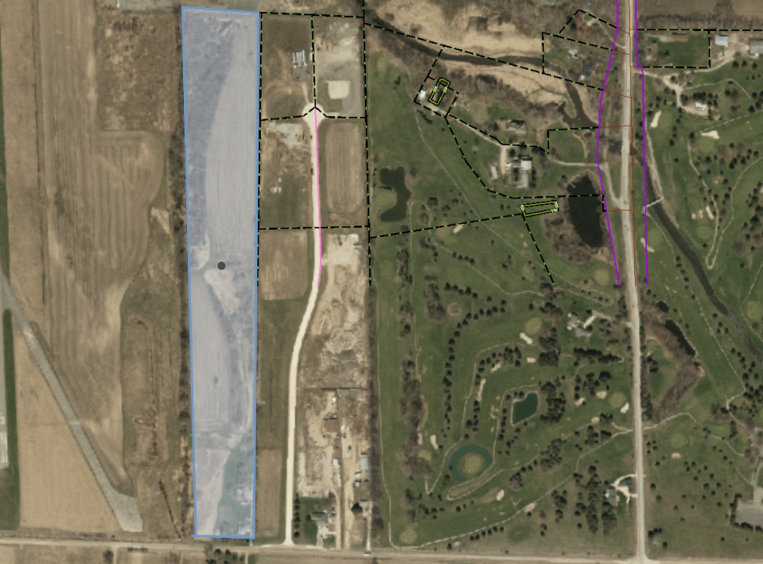
Brian Dr.
31 Mile Road
Aerial View of Subject Property
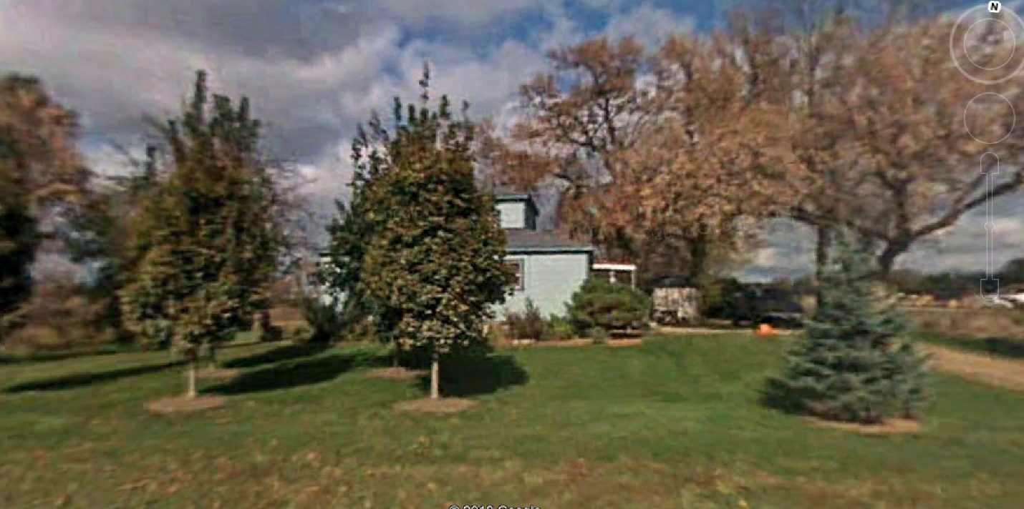Street View of Subject Property Looking from the South

COMPLIANCE WITH THE ZONING ORDINANCE

Section 1601 of the Ray Township Zoning Ordinance allows indoor industrial facilities in the I-1 Light Industrial District as a principal use. Section 1602 allows the outside storage of contractor’s equipment and supplies as a Special Land Use within the district.

The ordinance also requires compliance with several other standards, which are detailed below:

Dimensional Requirements

 | Required | Proposed | Compliant
Front Yard Setback (31 Mile Road) | 110’ | 250’
Rear Yard Setback | 30’ | 2,294’
Side Yard Setback(s) | 15’ | 60’, 194’
Height | 35’ | 24’

Parking Requirements

 | Required | Proposed | Compliant
Standard Parking Spaces | 10 | 11
Barrier Free Parking Spaces | 1 | 1
Maneuvering Lane Minimum Width | 24’ | 24’
Parking Space Size | 10’ x 20’ | 10’ x 20’

Landscaping Requirements

 | Required | Proposed | Compliant
Parking Area Landscaping | Yes | 2
Frontage Landscaping | 1 tree per 25’ of frontage | 13

General Comments

- The intended use of the existing house should be indicated on the site plan.
- The driveway approach and tapers adjacent to 31 Mile Road are subject to review and approval of the Macomb County Department of Roads, and the Township Engineer.
- It is recommended that the garbage dumpster be located outside of the enclosed fenced storage area, to facilitate easier access for trash hauling trucks.
- The proposed location of the sign along 31 Mile Road is within the required front yard setback. This needs to be relocated in compliance with the zoning ordinance.

SPECIAL LAND USE REQUIREMENTS

In addition to compliance with the above referenced requirements, the Planning Commission prior to granting Special Land Use approval, must also find that each of the following special land use standards are met.

- The proposed special land use will be of such location, size, and character that it will be harmony with the appropriate and orderly development of the area.
The adjacent area is master planned and zoned for industrial uses.

- The use will be of a nature that will make vehicular and pedestrian traffic no more hazardous than is normal for the district involved.
The proposed use is not expected to generate excessive traffic.

- The proposed use will be designed so that the location, size, intensity, site layout and periods of operation, eliminate excessive nuisances to surrounding areas.
The proposed use is not expected to create nuisances to surrounding properties.

- The proposed use will be such that the location and height of buildings or structures will not interfere or discourage appropriate development in the area.
The proposed use is consistent with the development trends of the area.

- The proposed use is so designed, located, and proposed to be operated that the public health, safety, and welfare will be protected.
The proposed use is in compliance with township ordinances.

- The proposed use will not cause substantial injury to the value of other property in the area.
The proposed use is consistent with the development trends of the area.

RECOMMENDATION

Based on the above findings, I recommend approval of the site plan subject to:

- Compliance with all Township engineering, building, assessing, and fire department requirements, and all Macomb County requirements relative to roads, drainage, and septic.
- Amending the site plan to relocate the dumpster and sign.
- Indicating the proposed use of the existing home.

Cassin stated that the applicant is not asking for approval of the sign at this time.

Penzien stated that the correspondence received will be read into the record, all correspondence is on file and available for review.

Penzien noted that the applicant has received a permit from EGLE (Michigan Department of Environment, Great Lakes, And Energy Water Resources Division.

Zoccola read correspondence received from the Macomb County Public Works into the record.

Marberg read correspondence received from the Ray Township Fire & Rescue into the record.

Kaniuk read correspondence received from the Macomb County Health Department into the record.

Stier read correspondence received from the Macomb County Department of Roads into the record.

Forro read correspondence received from the Ray Township Building Department into the record.

Lease read correspondence received from Lyle Winn, AEW, Township Engineer into the record.

Penzien asked if anyone other than applicant has any comments.

MOTION by Zoccola supported by Stier to close the public hearing at 7:17 P.M.
MOTION carried.

Penzien stated there are many comments and issues related to the site plan and not the special land use.

Penzien asked Mr. Cassin why the applicant is required to apply for a Special Land Use?

Cassin advised the outside storage requires Special Land Use Approval.

Robert Oliver stated he will be storing construction equipment and 21AA which is the base material for asphalt. Current site location is five (5) acres and need larger area.

Forro asked if they will be making asphalt on the site?

Oliver advised no.

Lease asked how much 21AA will be stored on the site.

Oliver advised most deliveries of 21AA are approximately 1,000 tons. Approximately 30 feet wide, 60 feet long and 15 feet tall.

Penzien asked Cassin if that fits in the area?

Cassin advised yes.

MOTION by Stier supported by Lease to approve the Special Land Use Application for outdoor storage of equipment and materials at 16077 31 Mile Road, Parcel ID # 21-05-06-401-003, JRO Properties Management, LLC. Applicants.
FOR THIS MOTION: Yes: Stier, Lease, Zoccola, Kaniuk, Forro, Marberg, Penzien
No:
MOTION carried.

Penzien stated the board would now discuss the Site Plan Application for 16077 31 Mile, Parcel ID # 21-05-06-401-003, JRO Properties Management, LLC.

Penzien asked applicants if they have received copies of all the correspondence submitted to the Township?

Oliver advised yes.

Stier stated he would like to a Knox Box to the list of items required by Ray Township Fire and Rescue Department.

Penzien asked if a dry hydrant and cistern were required in the area of Brian Drive?

DeMan stated all buildings on Brian Drive either have to have a cistern or an open pond. A dry hydrant is required for the cistern or the pond. Mandarino Construction on Brian Drive recently received approval and is also required to provide one of the two options above.

Nikkel asked if all industrial buildings in Ray are required to have dry hydrants/cisterns or detention ponds?

DeMan stated all industrial buildings over a certain size must provide a water source under the International Fire Code, Ray Township has adopted the International Fire Code.

DeMan stated when Brain Drive was built 20+ years ago the Fire Department requested a pond be put in to service the entire drive, developers did not want to do it and refused to install.

Stier asked if a community pond is an option?

DeMan stated Mandarino Construction has spoken with the fire department about different options to meet the requirement.

Nikkel stated that this is not a commercial building it is an industrial storage building; use cannot be constrained the same as commercial.

DeMan stated a fire wall separating the building may be a less expensive option.

Penzien asked the applicant if they are comfortable with the Macomb County Health Departments comments and the Macomb County department of Roads comment?

Oliver stated he is meeting with the Department of Roads on Wednesday June 12, 2019 and will contact the Health Department regarding the comments.

Penzien asked the applicants if they have reviewed all the comments from Lyle Winn, Township Engineer?

Nikkel stated they have met one with the Permit from EGLE.

Penzien questioned the intended use of the existing home and the need to state the use of the home on the plan.

Oliver stated the home has been used as a rental and will continue to be used as such. A long-term employee will be occupying the home.

Penzien asked Cassin if the home can continue to be a rental.

Cassin advised the rental can continue as a non-conforming structure.

Stier asked about fencing of the property.

Oliver stated it will not be 100% enclosed, they will be fencing the front and East side.

Penzien asked the application if they could meet the engineer’s requests?

Nikkel stated the Camp Brook Drain is no longer recognized by the County and questioned the Township engineers’ concerns.

Stier asked if the dumpster would be inside or outside the fenced area?

Oliver stated he would rather have inside; it is not a community dumpster.

Zoccola stated he agrees with placing dumpster inside fenced area, should leave inside.

Cassin stated the location of the dumpster needs to be noted on the site plan.

Penzien stated there are many different comments and reviews have been received related to the site plan.

Cassin stated the board should follow recommendations to make a motion.

MOTION by Lease supported by Stier to approve the site plan for JRO Properties Management, LLC at 16077 31 Mile Road, Parcel ID 21-05-06-401-005 contingent upon meeting compliance with all Township engineering, building, assessing, and fire department requirements, and all Macomb County requirements relative to roads, drainage, and septic.
Amending the site plan to relocate the sign.
Indicating the proposed use of the existing home.
FOR THIS MOTION: Yes: Lease, Stier, Forro, Zoccola, Marberg. Kaniuk, Penzien
No:
MOTION carried.

5. NEW BUSINESS

A. Site Plan Application, Commercial 68970 North Avenue, Parcel 21-05-01-100-005, Sunrise Stores, LLC – Dave Foster, Petitioner.

Chairman Penzien explained the planning commission site plan application procedure advising the audience that the Planner will present his findings for the application. The correspondences from the departments would be read into the record. Then the public should come to the podium, state their name, address and any concerns or comments they have on the item and the planning commission will further discuss the site plan application.

Mr. Cassin stated that over the last 2 weeks the Ray Township Zoning Board of Appeals granted approvals for the setbacks based on the hardship related to the parcel at the May 28, 2019 meeting and tabled the sign variance request to the June 4, 2019 special Zoning Board of Appeals meeting.

At the June 4, 2019 Zoning Board of Appeals meeting the Board granted variance approvals for the signs as revised and submitted.

Mr. Cassin, Planning Consultant presented his findings and recommendation dated June 4,2019 as follows:

GENERAL INFORMATION

Zoning: B-2 General Business
Location: 68970 North Avenue (southeast corner of North Ave. and 32 Mile Road)
Property ID: 21-05-01-100-005
Parcel Size: 1.958 acres of land (85,290 square feet)
Project Name: Sunrise Convenience Store and Gas Station
Case Number: PCI-19-002
Applicant: Dave Foster, Sunrise Stores
Review Date: June 4, 2019
ANALYSIS
PROPERTY CHARACTERISTICS

The property, located at the southeast corner of North Avenue and 32 Mile Road, is zoned B-2 General Business, and is developed with a convenience store. The main building is currently under construction for a small addition and new roof.

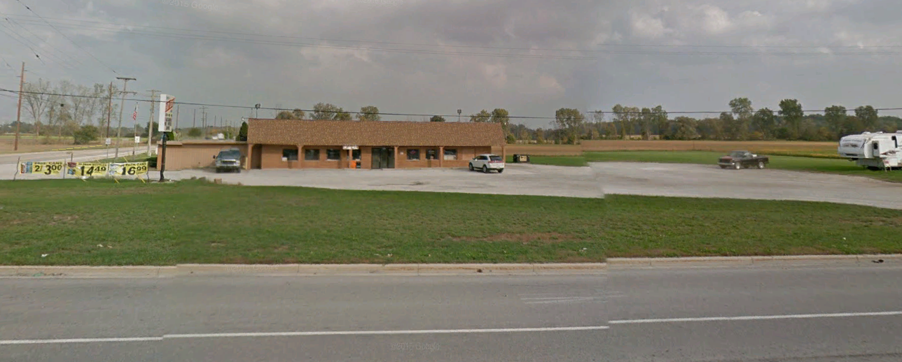

PROPOSAL

The applicant is proposing to make various improvements to the site, including the installation of 11 gasoline pump islands and a 62’ x 196’ gasoline canopy on the south side of building. In addition, two monument/pylon signs are indicated on the site plan.

COMPLIANCE WITH THE ZONING ORDINANCE

Section 1601 of the Ray Township Zoning Ordinance allows convenience stores and gasoline service stations in the B-2 district as a principal permitted use.

The ordinance also requires compliance with several other standards, which are detailed below:

Dimensional Requirements

 | Required | Proposed | Compliant
Front Yard Setback | 110’ | 250’
Rear Yard Setback | 30’ | 115’
Side Yard Setback(s) | 15’ | 20’
Height | 35’ | 24’

The site plan, as submitted, proposes several improvements within the required front yard setback, including signage, gas pumps, a gas pump canopy, lighting, a septic field, off-street parking, maneuvering lanes, and a water tank.

The applicant received variances to encroach into the required front yard setback from the Zoning Board of Appeals on May 28, 2019.

Parking Requirements

 | Required | Proposed | Compliant
Standard Parking Spaces (retail store) | 15 | 18
Barrier Free Parking Spaces | 2 | 2
Maneuvering Lane Minimum Width | 24’ | 24’
Parking Space Size | 10’ x 20’ | 10’ x 20’

Landscaping Requirements

 | Required | Proposed | Compliant
Parking Area Landscaping | 1 tree per 5 spaces | 0
Frontage Landscaping (North Ave.) | 1 tree per 25’ of frontage (15) | 6 shrubs  at sign base
Frontage Landscaping (32 Mile) | 1 tree per 25’ of frontage (8) | 8 shrubs  at sign base

The site plan needs to be revised to indicate the required landscaping.

Signage

 | Allowed | Proposed | Compliant
Number of signs | 2 | 2
Sign Height | 6’ | 21.57’
Sign Area | 64 square feet | 200 square feet

The site plan indicates two monument/pylon signs, one on 32 Mile Road and the other on North Avenue. The signs exceed the ordinance height limit by 15.57’, and the area limit by 136 square feet per sign.

The applicant received variances to exceed the area and height limit for both signs from the Zoning Board of Appeals on June 4, 2019.

RECOMMENDATION

Based on the above findings, and the granting of variances by the Zoning Board of Appeals, I recommend approval of the site plan subject to:
- Revisions to the site plan to indicate the required landscaping.
- Compliance with all Township engineering, building, assessing, and fire department requirements.
- Compliance will all Macomb County requirements relative to roads, drainage, and on-site septic disposal.

Penzien stated that the correspondence received will be read into the record, all correspondence is on file and available for review. ‘
Marberg read correspondence received from the Ray Township Fire & Rescue into the record.

Forro read correspondence received from the Macomb County Health Department into the record.

Kaniuk read correspondence received from Lyle Winn, Township Engineer into the record.

Stier read correspondence received from Macomb County Public Works into the record.

Lease read correspondence received from Dennis LeMieux, Ray Township Building Official into the record.

Stier read the Macomb County Department of Roads comments written on the site plan into the record.

Penzien asked if a public hearing was held for this matter.

Hall advised the Ray Township Zoning Ordinance does not require a public hearing for site plan review.

Penzien asked Mr. Foster if his written correspondence is response to Lyle Winn’s comments or for the planning commission?

Penzien requested Mr. Fosters response be included in the file and forwarded to Mr. Winn.

Forro stated he does not believe Mr. Winn has seen the correspondence from Foster.

Cassin stated that items number 1, 2 and 4 in Mr. Winn’s review are planning not engineering and all planning issues have been resolved. Number 3 is an engineering issue.

Foster advised that all asphalt will be eight (8”) inches.

Penzien asked Foster if they feel they can address all the issues related to engineering?

Foster stated; his engineer has advised more water storage is needed on the site, and is calculating the amount of water needed.

Foster stated in reference to item 2 from Mr. Winn, variances were received to allow construction on the existing building. Plans were submitted and building permits issued for the all construction.

Foster stated they have planned to put 22 trees along the South and East property lines, what is required on 32 Mile and North Avenue for landscaping?

Penzien asked Foster if they are willing to meet the landscaping requirements?

Foster advised they will revise the landscaping on the site plan to meet the requirements of the ordinance.

Forro asked about item 9 and the gas tank location near the property lines.

Foster advised the system they use to install underground gas tanks ensures that they will not be encroaching on any adjacent parcel. They build a box that contains the entire tank system and complies with all State of Michigan requirements.

Foster commented related to item 8 from Mr. Winn. Winn stated the topographical survey should include more than one benchmark. Foster stated benchmarks are usually related to a drain or fire hydrant. There are none on the site, but he will locate and provide a second benchmark.

Stier advised that a Knox box needs to be included on the Fire Department requirements.

Foster stated a Knox box will be included.

Forro stated, I do not feel comfortable, Lyle Winn needs to see comments.

Foster stated their engineer has been in contact with Mr. Winn.

Penzien stated that an approval can be given contingent upon meeting all the conditions of engineer and other departments have been met.

Lease asked if a provision can be made in the motion that all engineers comments are addressed and no building permits be issued.

Lease asked who would be responsible to make sure all comments have been addressed.

Cassin advised the Building, Planning and Zoning Department would make sure all conditions are met.

Hall advised that Dennis LeMieux and Steve Cassin would review and approve everything before any permits are issued.

MOTION by Marberg supported by Zoccola to approve site plan for Sunrise Stores, LLC, at 68970 North Avenue, Parcel ID 21-05-01-100-005 based on findings provided by Township Planner and ZBA approvals and contingent upon the following:
1. Revisions to the site plan to indicate the required landscaping.
2. Compliance with all Township engineering, building, assessing, and fire department requirements.
3. Compliance will all Macomb County requirements relative to roads, drainage, and on-site septic disposal.
4. Building, Planning and Zoning Department to complete review of all requirements prior to issuing any building permits related to site plan approval.
FOR THIS MOTION: Yes: Marberg, Zoccola, Lease, Kaniuk, Penzien
No: Forro, Stier

Board members and Foster continued discussion regarding site.

5B. Update Parks and Recreation Plan:
Cassin provided a copy of a survey for the planning commission to review for the parks and recreation master plan update. Requested input from board members that night for changes or edits. The survey will not be coming back to the planning commission before it becomes available to the residents.

Lease asked how will the residents be made aware of the survey.

Cassin advised that the survey link will be posted on the Township website and hard copies of the survey will be available at the library and the township hall. Will also have copies available at Ray Day.

6. Old Business: None

7. PRESENTATION – None

8. REPORT OF THE BOARD REPRESENTATIVE: Stier had nothing to report.

9. REPORT OF THE ZONING BOARD OF APPEALS REPRESENTATIVE: - Penzien advised that the ZBA approved variances to setbacks, exceed square footage of accessory buildings permitted and Depth to Width Ratios on Hayes Road. Approved setback variances for two different parcels on North Avenue and approved sign variances for Sunrise Stores on North Avenue.

10. CORRESPONDENCE – None

11. PLANNING CONSULTANTS REPORT. –
Cassin stated that the zoning ordinance is being reviewed and some ordinance changes need to be made, some examples include:
Tree/Shrub Nurseries in the R-1 district table and R-1 Residential-Agricultural permitted uses are currently not the same.
Temporary Use
Fencing
Total size of all permitted accessory structures.
Signs – Recent supreme court case, cannot regulate based on content.

Penzien asked when the Master Plan needs to reviewed.

Cassin advised 2020.

12. PUBLIC COMMENTS – None

13. ADJOURNMENT.

MOTION by Stier supported by Marberg to adjourn the meeting at 8:32 p.m.
MOTION carried.

Tom Penzien, Chairman Randy Forro, Secretary Date

Respectfully submitted,
Lisa Hall, Recording Secretary

