TOWNSHIP OF RAY
Board of Trustees
Joseph Jarzyna, Supervisor
Lori Lascoe, Clerk
Douglas Stier, Treasurer
Charles Bohm, Trustee
Betty Grader, Trustee
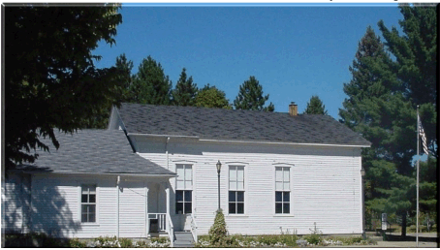
County of Macomb

64255 Wolcott Road Ray Township, MI 48096 (586) 749-5171
Fax (586) 749-6190 Website www.raytownship.org

June 28, 2019

Blue Water Gas Compressor Station – Omo Rd., Ray Twp.

To Whom It May Concern,

On behalf of the residents of Ray Township, which is a neighboring Township to Lenox Township, please let me express some concerns that we have regarding the proposed Omo Compressor Station.

- Our community has experienced an unusually dense grouping of catastrophic failures at similar facilities (two of these facilitations were owned by Blue Water). These were the Blue Water Columbus facility (January 21, 2011), The Blue Waterfront/Vector Booster Station (June 7, 2014), and the Consumers Omo Road facility (January 30, 2019).

- None of these incidents caused the loss of human life, but neighbors recall incidents of livestock being killed, houses shaking from the blast and causing other damage.

- This pattern of incidents raises our concern about a facility being installed along the road with nearby residences and lots for future residences.

- Other locations were and are available to Blue Water at a safer distance from any homes. We understand that the choice of this specific spot was economically motivated. But economic considerations need to be balanced against the safety of our residents. Reportedly, representatives of Blue Waters parent company, WEC, said that they were unwilling to consider other locations due to cost.

- The residents of Ray Township will have to live with the inherent dangers posed by this facility and yet receive no benefits whatsoever. As reported in their FERC application, the end users of this gas pipeline are located in Wisconsin, allowing users in Wisconsin to receive gas at a lower cost. No one in Lenox Township or here in Ray Township will use any of the gas being provided.

- It seems, at the very least, inequitable to allow this station to be planned at the lowest allowable safety standards when the only thing it add to our community is risk.
- Blue Water’s poor safety record should give FERC pause in approving their application.

- Those who chose to live in Lenox and/or Ray Township and other similar communities chose to do so for the peaceful rural atmosphere. This compressor will certainly disrupt dozens of families from the quiet enjoyment of their homes. The constant humming, the onsite industrial complex, and the concern that a sudden failure could injury or kill someone and/or damage property will certainly impact the value of the property in these areas.
- If it is impossible to have this station moved to a more remote location, perhaps an earthen berm should be erected on all four sides of the facility. Also, conifer trees could be utilized on top of the berm to muffle sounds and obscure the unsightly facility.
Your attention to this letter is greatly appreciated.

I remain,

Respectfully,

Joe Jarzyna
Ray Township Supervisor

