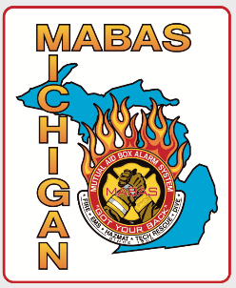
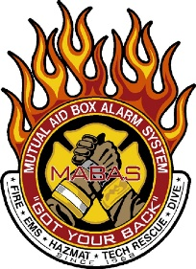
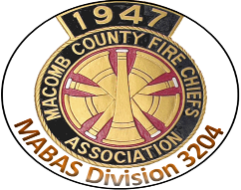

Press Release
Michigan Fire Departments
Exercise Statewide Disaster Mutual Aid Activation

February 13, 2020
On February 12, 2020 Macomb County Fire Departments took part in the Michigan Mutual Aid Box Alarm System (MABAS) Engine Strike Team Exercise. 16 counties from across Michigan took part in the exercise that simulated the deployment of critical firefighting resources to other areas of the State, in a coordinated effort. Each Strike team was made up of 5 Fire Engines, each with 4 Personnel, a Strike Team Leader and an Assistant. In all, 80 Fire Engines, 16 Command Vehicles with over 250 Firefighters from across the state took part in the exercise. Each department was activated by their local 911 Center, after being contacted by the MABAS “RED” Center (Regional Emergency Dispatch) requesting that all apparatus report to a pre-designated local point of departure. Once the fire personnel and equipment arrived at their point of departure, they notified their local 911 Center that they had arrived and were ready for deployment.
“The purpose of the activation was to exercise Michigan’s Fire Department Mutual Aid system, its capability to move fire resources during a disaster, and to test our statewide communications,” stated Fire Chief Brian Ball, President of Michigan MABAS. “At any time one of our communities can be faced with a natural or man-made disaster that requires more resources than the communities or their surrounding communities can provide, that’s when our statewide system of Fire Department Mutual Aid resources are activated,” stated Chief Ball.
Michigan MABAS is an organization ran by its participating fire departments. MABAS maintains a system and communications for activating and moving fire department resources across the State of Michigan. Michigan MABAS has over 550 participating fire departments in over 30 counties. Later this year MABAS will be exercising other resource activations in an effort to prepare for any disaster, fire, hazardous materials incident, or special rescue.
All Fire Departments in Macomb County are organized under MABAS as Division 3204. The Engine Strike Team for Division 3204 is made up of Engines from every agency in Macomb County, under a defined quarterly rotation. For this quarter, the response called for a Fire Engine from Bruce Township, Clinton Township, Mt. Clemens, Ray Township with merged staffing from Armada Township and Sterling Heights. The Strike Team Leader for this quarter was the Battalion Chief from Clinton Twp. This was also an exercise between two dispatch centers in Macomb County as SERESA is the MABAS Divisional Dispatch for Macomb County/Division 3204 and COMTEC is the Dispatch provider for all of the departments that took part in the exercise.

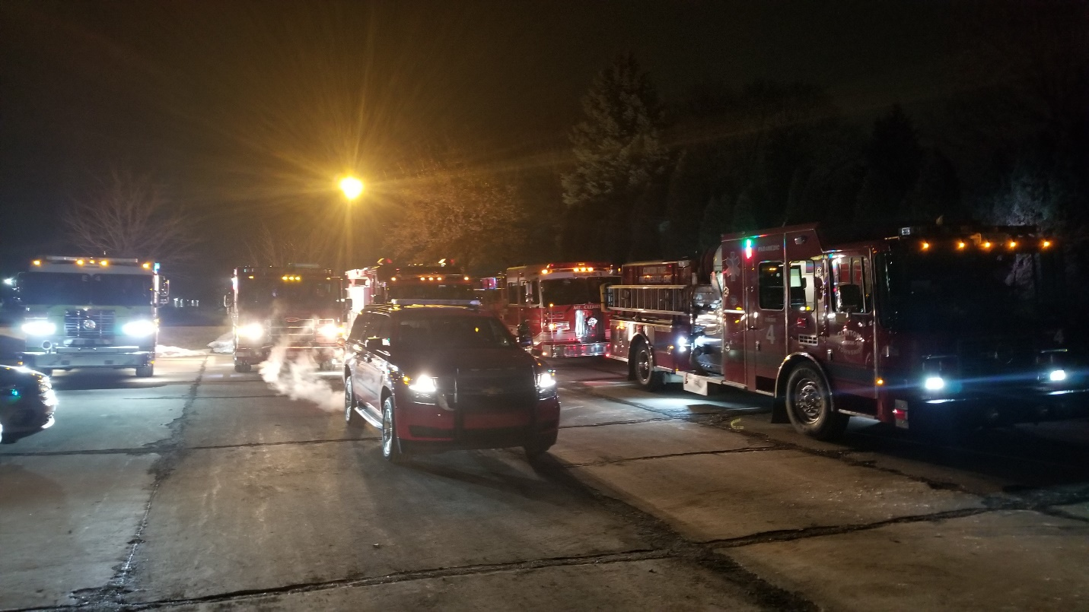
From left to right in the rear, Bruce Twp E1, Sterling Heights E2, Ray Twp E1 (Merged Staffing with Armada Twp), Mt. Clemens E1. Front Row, Strike Team Leader Clinton Battalion 1, Clinton E4

For Further information, please contact
Sterling Heights Fire Chief Chris Martin; President Macomb County Fire Chiefs, Vice President Michigan MABAS cmartin@sterling-heights.net 586-446-2951
St. Clair Shores Fire Chief Jamey Piper; MABAS Division 3204 Representative piperj@scsmi.net 586-445-5380
Washington Township Fire Chief Brian Tyrell; MABAS Division 3204 Plans Coordinator tyrellb@ctwfd.org 586-781-6161

