Location: Ray Township Hall
64255 Wolcott, Ray MI 48096

Present: Harold DeMan Jr., Chairman
Scott Mathews, Vice-Chairman
Members: Tom Penzien
Betty Youngblood

Absent: Marvin DeBuck, excused.

Also Present: Steven Cassin, Planning Consultant & Lisa Hall, Planning & Zoning Clerk
Attendance record on file.

- CALL TO ORDER- PLEDGE OF ALLEGIANCE AND ROLL CALL.
Chairman DeMan called the meeting to order at 7:00 p.m. The Pledge of Allegiance was recited. All members were present.

- APPROVAL OF AGENDA
MOTION by Mathew supported by Penzien to approve the agenda as presented.
MOTION carried.

- APPROVAL OF MINUTES: August 28, 2018
MOTION by Mathews supported by Youngblood to approve the meeting minutes of August 28, 2018 as presented.
MOTION carried.

- Scheduled Public Hearings-
Request for the following variances to Township Zoning Ordinance: Section 400
(R-1 Agricultural Residential; Minimum Front Yard Setbacks. 63011 Indian Trail, Property ID 21-05-15-477-005, Paul Kowalweski, Applicant

Chairman DeMan explained the public hearing procedure, the planner would explain the variance request so the audience will be informed on the variance request. Then the public hearing would be open for the public to come to the podium, state their name and address and state any comments they may have regarding the agenda item.

Mr. Cassin, Planning Consultant, presented his findings and recommendation, dated September 16, 2018. They are as follows:
Proposal
To construct a 32’ x 44’ (1,408 square foot) attached garage and a 30’ x 48’ (1,440 square foot) accessory structure, within the required front yard setbacks.
Property Characteristics
The property is located at the northwest corner of Indian Trail and 29 Mile Road and contains a single-family home (built in 2016), and a detached garage that predates the home. The parcel also contains a pond and a significant area of mature trees. Furthermore, the 100-year flood hazard zone traverses the western portion of the property.
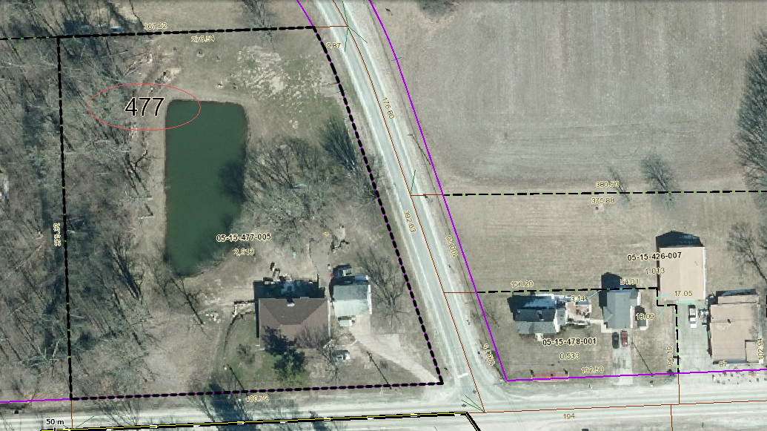
Analysis
Section 400 of the Ray Township Zoning Ordinance requires a front yard setback of 93 feet from the centerline of Indian Trail, and a setback of 110 feet from the centerline of 29 Mile Road. The proposed attached garage would be (at its closest point) 61 feet from the centerline of Indian Trail and 102 feet from the centerline of 29 Mile Road. In this regard the attached garage would encroach 32 feet into the required Indian Trail setback, and 8 feet into the required 29 Mile Road setback.
The proposed accessory structure would be (at its closest point) 73 feet from the centerline of Indian Trail, therefore encroaching 20 feet into the required Indian Trail setback.
Attached Garage
Road | Road Classification |  | Required setback from centerline of Road | Proposed Setback | Setback Variance Required
Indian Trail | Collector Road |  | 93 Feet | 61 Feet | 32 Feet
29 Mile Road |  | Major Road | 110 Feet | 102 Feet | 8 Feet
Accessory Structure
Road | Road Classification | Required Setback from centerline of Road | Proposed Setback | Setback Variance Required
Indian Trail | Collector Road | 93 Feet | 73 Feet | 20 Feet

The following diagram depicts the buildable portion of the lot after allowing for the required setbacks.
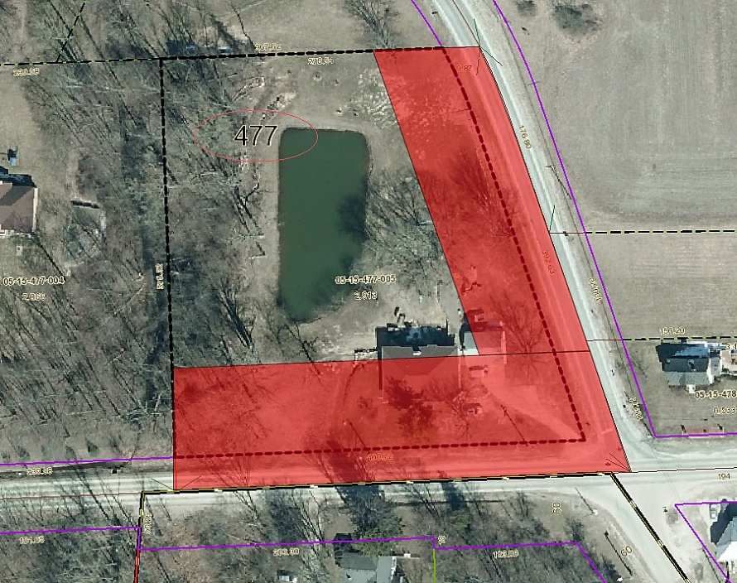

Authority of the Zoning Board of Appeals
Section 2706 of the Ray Township Zoning Ordinance specifies that variances may be granted if the Zoning Board of Appeals finds:
- The strict enforcement of the Zoning Ordinance would cause practical difficulty and deprive the owner of rights enjoyed by all other property owners owning property within the same zoning district.
- The conditions and circumstances are unique to the subject property and are not similarly applicable to other properties in the same zoning district.
- The conditions and circumstances unique to the property were not created by the owner or his/her predecessors in title, within the time following the effective date of the provisions alleged to adversely affect such property.
- The requested variance will not confer special privileges that are denied other properties similarly situation and in the same zoning district.
- The requested variance will not be contrary to the spirit and interest of the Township Zoning Ordinance.

Recommendation
The parcel is oddly shaped due to Indian Trail running on a northwesterly – southeasterly diagonal. The property contains a flood plain and mature stand of trees. These features, together with two required front yard setbacks, make the property extremely difficult to build upon. The conditions are unique to property, and have not been self-created. In addition, the requested variance will not confer special privileges that are denied other properties in the area, and will not be contrary to the spirit and interest of the Township Zoning Ordinance. Approval of the requested variances is recommended.

Chairman DeMan read the following correspondences:
6-13-2018 Dennis LeMieux, Building Official had no issues with the variance for the property.
MOTION by Penzien supported by Youngblood to open the public hearing at 7:06 p.m.
MOTION carried.

Ms. Youngblood asked what the size of the new attached garage would be in comparison to the existing garage.
Mr. Kowalewski existing garage is approximently 800 square feet.

MOTION by Penzien supported by Mathew to close the public hearing at 7:08 p.m.
MOTION carried.

Penzien asked if the proposed buildings would be encroahing into the Macomb County Right-of Way on 29 Mile or Indian Trail?
Cassin advised the proposed buildings would be constructed in the Townships setbacks not the Countys Right of Way
Penzien stated he just wanted to be clear that neither of the proposed buildings would be constructed in the County future right of way.
Penzien questioned why the new accessory building cannot be closer to the West side of the property? Is it due to the pond and elevations? Will the existing garage be torn down and can the proposed new attached garage be moved North to meet the setback from 29 Mile?
Kowalewski advised the pond prevents moving the accessory building to the West and the attached garage cannot be moved to the North due to the septic line.
Penzien stated that other properties are not restricted in this way and this is unique to this parcel due to the frontages on Indian Trail and 29 Mile Road.
DeMan asked if the existing driveway will be removed and a new driveway will be created?
Kowalewski advised yes the old driveway will be eliminated and the new driveway based on Macomb County Department of Roads approval.

MOTION by Penzien supported by Mathews to approve three variances to Section 400, Minimum Front Yard setbacks as submitted to the ZBA and to allow construction of an attached garage and accessory structure within the minimum Front Yard Setbacks.
FOR THIS MOTION: Yes: Penzien, Mathews, DeMan, Youngblood

6. Report from the Planning Commission Representative: Nothing to report

7. Public Comments: Mr. Kowalewski thanked the Zoning Board of Appeals.

8. Adjournment
MOTION by Mathews supported by Youngblood to adjourn the meeting at 7:17 p.m.
MOTION carried.

Harold DeMan, Chairman Marvin DeBuck, Secretary Date

Respectfully submitted,
Lisa Hall, Recording Secretary
Township Clerk

