TOWNSHIP OF RAY
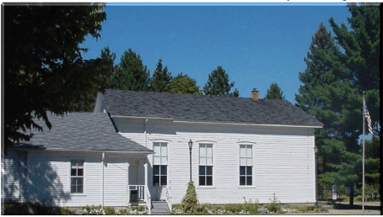
Board of Trustees
Joe Jarzyna, Supervisor
Lori Lascoe, Clerk
Douglas Stier, Treasurer
Charles Bohm, Trustee
Betty Grader, Trustee
64255 Wolcott Road Ray Township, MI 48096 (586) 749-5171
Fax (586) 749-6190 Website www.raytwp.org
County of Macomb

Planning Commission Agenda
Date: Tuesday, January 8, 2019
Time: 7:00 p.m.
Location: 64255 Wolcott, Ray, MI 48096

1. Call to Order – Pledge of Allegiance – Roll Call
2. Approval of Minutes – November 13, 2018
3. Approval of Agenda

4. Old Business
Special Land Use/Site Plan Application, Private Road, 8 Parcels, 15632 29 Mile Rd,
Parcel ID 21-05-19-100-004 Tony Virelli, Petitioner – Tabled from October 9,2018 Meeting

Discussion Capital Improvements Plan – nothing further to report at this time.

5.Scheduled Public Hearings:
A. Rezoning Request: Agricultural -Residential (R-1) to Industrial (I-1) Industrial for Permanent Parcel 21-05-36-100-024; Located on the East side of North Avenue between 26 and 27 Mile Road, Anthony Stadler, Petitioner
Presentation by Planning consultant
Read Correspondence
Open for public comment and question
Discussion by Planning Commission

B. Public Hearing Regarding Amendments to Ray Township Zoning Ordinance #36
Inserting Section 3001 – Definition – Agricultural – Tourism, Inserting Section 1700 R – Agricultural Tourism
Inserting Section 2500 A 6 – Private Roads
Inserting Section 1.025 A Definitions – Dedicated Landscape Area, Adding Section 3.05 Dedicated Landscape Area.
Presentation by Planning consultant
Read Correspondence
Open for public comment and question
Discussion by Planning Commission

6. New Business
7. Presentation
8. Report of the Township Board Representative
9. Report of the Zoning Board of Appeals Representative
10. Correspondence
11. Planning Consultants Comments
12. Public Comment
Lisa Hall, Planning and Zoning Director

