TOWNSHIP OF RAY
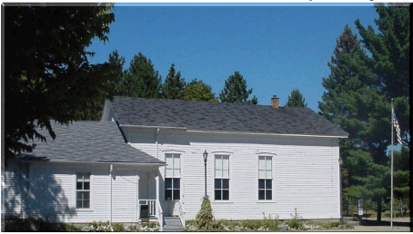
County of Macomb

64255 Wolcott Road Ray Township, MI 48096 (586) 749-5171
Fax (586) 749-6190 Website www.raytownship.org

2019 SOFTBALL LEAGUE FIELD USE AGREEMENT

TEAM NAME:__________________________________________________________

MAIN CONTACT NAME:__________________________________________________

PHONE:_____________________________________

ADDRESS: __________________________________CITY:________________ZIP:_____________

ALTERNATE PHONE:______________________________________________________________

E-MAIL:__________________________________________________________________________

Please read the rules governing park usage and sign the acknowledgment on the reverse side of this document.

- No cars or other motorized vehicles shall be permitted around the baseball diamonds. Please use the park lane located on the North side of the building for parking.
- Permit holders are responsible for policing and cleaning the ball diamond and surrounding areas after use. Please put trash in receptacles.
- Permit applicant is responsible for any damages incurred by their group.
- Applicant must have permit in his possession on scheduled day of usage.
- Ball Diamonds are available from 9 a.m. until dusk. Park is closed at dusk.
- Permission must be obtained from the Township prior to assembly of tents, canopies and portable restrooms. Request must be made in a written format two weeks prior to the rental.
- Absolutely no alcoholic beverages or controlled substances are allowed in the park.
- These reservations are subject to cancellation if a Township event or Park Reservation is scheduled, we will notify you of any change in advance when possible.
- To report facilities problems; please call the township office during business hours (586) 749-5171 ext. 204.

Field Upkeep:
-Ray Township does not drag or chalk the softball diamonds. Anyone wishing to do so must contact the Ray Township office prior to doing so.

Equipment:
-Ray Township does not stock or supply any bases or to other softball diamond supplies. It is the responsibility of the group wishing to reserve the diamonds to provide their own equipment.

Insurance – Is required by the Township of Ray, the permit holder shall name the Township as an additional insured on any applicable Casualty or Liability Insurance. Copies must be on file in the Township Hall.

The holder of this permit shall indemnify, defend and hold harmless the Township, including Township Officers, Employees and Agents from and against all liabilities, losses, expenses, damages, fines, penalties, claims, suits and actions brought against the Township (including all related costs, actual and reasonable attorney fees and expenses) that result, directly or indirectly from the permit holder’s use of the premises specified in this permit.

I have read the above general rules governing the use of all Ray Township pavilions/fields and agree to have my group abide by them.

TEAM NAME_________________________

DATE(s) | DAY | TIME | DIAMOND # | APP. # OF PEOPLE

Signature of Permit Holder ___________________________________________________________

Date _______________

Approved by _______________________________________________________________________

Date _______________

