Location: Ray Township Hall
64255 Wolcott, Ray MI 48096

Present: Harold DeMan Jr., Chairman
Scott Mathews, Vice-Chairman
Members: Tom Penzien
Betty Youngblood
Absent: Marvin DeBuck, Secretary-Excused

Also Present: Steve Cassin, Planning Consultant & Lisa Hall, Planning & Zoning Clerk
Attendance record on file.

- CALL TO ORDER- PLEDGE OF ALLEGIANCE AND ROLL CALL.
Chairman DeMan called the meeting to order at 7:00 p.m. The Pledge of Allegiance was recited.
All members were present.

- APPROVAL OF AGENDA
MOTION by Penzien supported by Youngblood to approve the agenda as presented.
MOTION carried.

- APPROVAL OF MINUTES: March 26, 2019
MOTION by Mathews supported by Youngblood to approve the meeting minutes of March 26, 2019 as presented.
MOTION carried.

- Scheduled Public Hearings-
1. Request for two (2) variances to Section 400 - Lot Dimensions, Minimum Width to Depth Ratio. 19790 32 Mile Road, Parcel 21-05-04-200-002, Lawrence & Brennan Fraley, Applicants.

Chairman DeMan explained the public hearing procedure, the planner would explain the variance request so the audience will be informed on the variance request. Then the public hearing would be open for the public to come to the podium, state their name and address and state any comments they may have regarding the variance request.

MOTION by Penzien supported by Mathews to open the public hearing at 7:02 p.m.
MOTION carried.

Mr. Cassin, Planning Consultant presented his findings and recommendation dated April 10,2019 they are as follows:
GENERAL INFORMATION

Applicant: Lawrence and Brennan Fraley
Location: 19790 32 Mile Road (east of Wolcott Road)
Zoning District: R-1, Agricultural Residential
Property ID: 21-05-04-200-002
Size of Parcel: 40.93 acres
Action Requested: Request to split the property into 2 parcels, which requires width to depth ratio variances for each parcel.
ANALYSIS
PROPERTY CHARACTERISTICS

The property contains 40.93 acres, has approximately 511 feet of frontage on 32 Mile Road, and has a depth of 3,074 feet. The map below depicts the general location of the property.

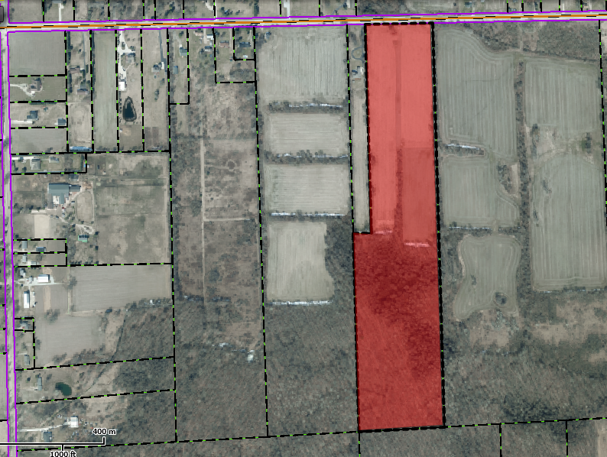
Wolcott Rd.
32 Mile Road
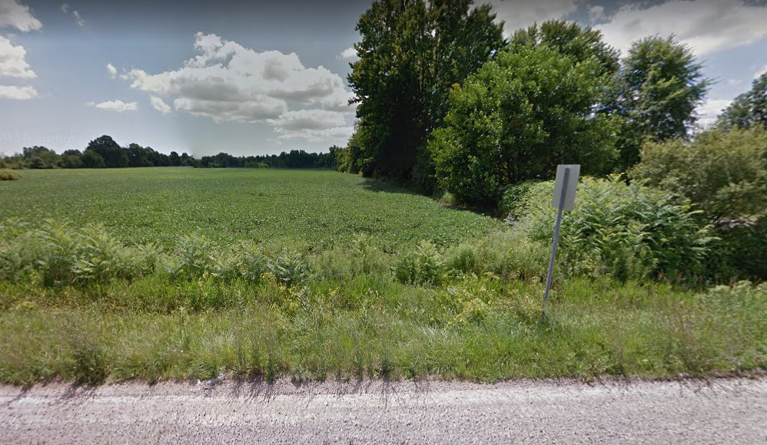
Street View (from the north)

ANALYSIS OF VARIANCE REQUEST

The applicant is proposing to split the existing parcel into 2 different parcels, each having 255.37’ of frontage on 32 Mile Road. The westerly parcel would contain 22.88 acres, and the easterly parcel would contain 18.04 acres,

Section 6.00-E-1 of the Ray Township Land Division Ordinance states that no division of land shall be approved by the Township Assessor unless all township ordinance requirements, including zoning ordinance provisions, are met.

Section 400 of the Ray Township Zoning Ordinance specifies a maximum 1:4 width to depth ratio for parcels within the R-1 zoning district. The two parcels (after splitting) would have a width to depth ratio of approximately 1: 12 (255.37 feet: 3073.66 feet), which would necessitate variances for both parcels. (It should be noted that the existing parcel does not comply with the width to depth ratio requirement and is considered legally nonconforming.)

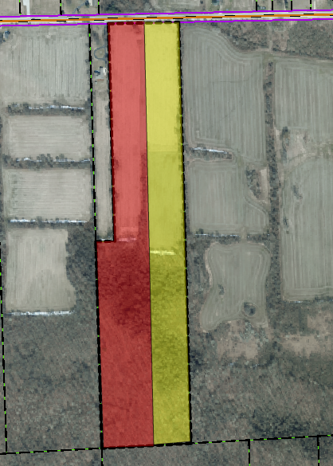
The current parcel (red and yellow) contains 40.93 acres and has a width to depth ratio of 1:6. This is a legal non-conforming lot.

After splitting, the easterly parcel (yellow) would have an area of 18.04 acres, and a width to depth ratio of 1:12
After splitting, the westerly parcel (red) would have an area of 22.88 acres, and a width to depth ratio of 1:12

AUTHORITY OF THE ZONING BOARD OF APPEALS
Section 2706 of the Ray Township Zoning Ordinance specifies that variances may be granted if the Zoning Board of Appeals finds that:
- The strict enforcement of the Zoning Ordinance would cause practical difficulty and deprive the owner of rights enjoyed by all other property owners owning property within the same zoning district.
- The conditions and circumstances are unique to the subject property and are not similarly applicable to other properties in the same zoning district.
- The conditions and circumstances unique to the property were not created by the owner or his/her predecessors in title, within the time following the effective date of the provisions alleged to adversely affect such property.
- The requested variance will not confer special privileges that are denied other properties similarly situation and in the same zoning district.
- The requested variance will not be contrary to the spirit and interest of the Township Zoning Ordinance.

RECOMMENDATION
It is my opinion that the existing conditions are unique to the property, due to the existing lot depth of approximately 3,083 feet. Furthermore, if the requested variances were granted, the created parcels of 22.88 and 18.04 acres would still significantly exceed the minimum required land area of 2.06 acres in the R-1 district. In addition, the lot widths of 255 feet, are greater than the district minimum of 150 Feet.
Therefore, I recommend approval of the variances, as requested.
DeMan read correspondence as follows:

4-8-2019 Dennis LeMieux, Building Official advised the building department has no objections to the proposed splits.

4-11-2019 Kelly Timm, Ray Township Assessor, the assessing department has reviewed the request for the variances requested on the above referenced parcel.
A variance is required to create Parcel A and Parcel B. Both lots exceed the 4:1 Depth to Width Ratio as outlined in the Ray Township Zoning Ordinance.
If approved the applicant is required to submit an application to the Assessor to process the slit.
If you should have any questions regarding this information, please feel free to contact me.

DeMan asked the applicant if he had any comment?

Fraley stated Brennan is his son and they purchased the property with the intention of splitting and eventually building homes on the 2 parcels. Fraley stated he hopes to start his home within one year and his son will build at a later date.
They have considered requesting additional splits if it is possible.

DeMan asked the board if anyone had any questions for the applicant?

MOTION by Penzien supported by Mathews to close the public hearing at 7:06 p.m.
MOTION carried.

Penzien asked Cassin if the parcel is currently not compliant, already long and narrow, now there will be two (2) long narrow parcels, is that a problem?

Cassin advised no.

Penzien asked if there was ever an option to create 90,000 square foot parcels?

Fraley stated they could possibly have split into more.

DeMan asked applicant who will be the owner of the larger parcel. Fraley advised he will be.

MOTION by Penzien supported by Mathews to approve the request for two (2) variances to Section 400, Lot Dimensions, creating two (2) lots exceeding the Minimum Width to Depth Ratio, existing parcel currently known as 19790 32 Mile Road, 21-05-04-200-002.
FOR THIS MOTION: YES: Penzien, Mathews, Youngblood, DeMan
NO: None
MOTION carried.

Scheduled Public Hearings-
2. Request to vary Section 215. Solar Panels. A. The use of solar panels and shingles (or the like) for private use shall meet the following requirements: 1. Freestanding, (a) Freestanding solar panels shall not be located in the front or side yard. 65780 North Avenue, Parcel 21-05-12-300-015, Kurt King, Applicant.

Chairman DeMan explained the public hearing procedure, the planner would explain the variance request so the audience will be informed on the variance request. Then the public hearing would be open for the public to come to the podium, state their name and address and state any comments they may have regarding the variance request.

MOTION by Penzien supported by Youngblood to open the public hearing at 7:09 p.m.
MOTION carried.

Mr. Cassin, Planning Consultant presented his findings and recommendation dated April 10,2019 they are as follows:

GENERAL INFORMATION

Applicant: Kurt King
Location: 65780 North Avenue (East side of North Ave, North of 30 Mile Road)
Zoning District: R-1, Agricultural Residential
Property ID: 21-05-12-300-015
Size of Parcel: 20.3 acres
Action Requested: Request variance to allow freestanding solar panels in the front yardNALYSIS
PROPERTY CHARACTERISTICS

The property has an area of approximately 20.3 acres, and is located on the east side of North Avenue, north of 30 Mile Road. It is currently zoned R-1 Agricultural Residential and contains an existing home and accessory building. The map below depicts the general location of the property.
North Avenue
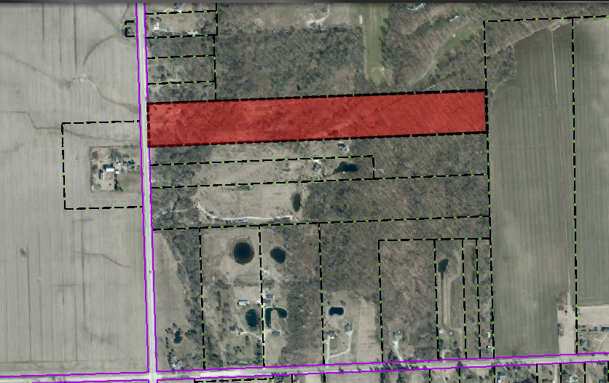
30 Mile Road

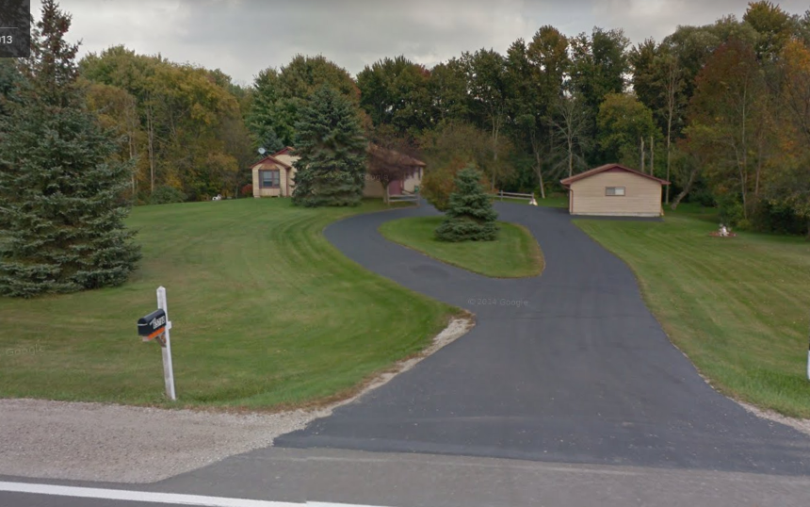

Street View (from west)

ANALYSIS OF VARIANCE REQUEST

The applicant is proposing to construct solar panels in the front yard, approximately 85 feet back from the road right-of-way. The total area of the solar panels is estimated at 1,200 to 1,500 square feet.

Section 215- A-1-a of the Ray Township Zoning Ordinance specifies that “freestanding solar panels shall not be located in the front or side yard”. However, the applicant is requesting considering to construct the solar panels in the front yard, due to a large area of floodplain traversing the property, which makes construction in the rear yard very difficult. The drawing below indicates the flood plain on the property.

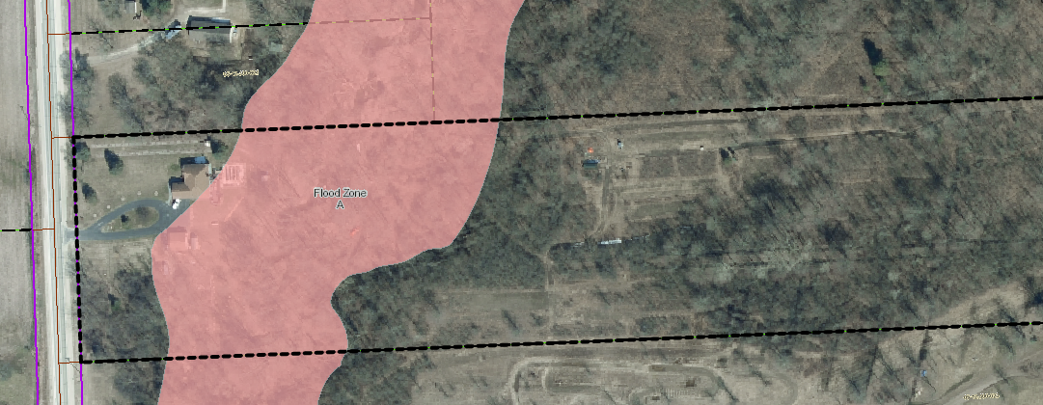
Approximate location of Solar Panels
Flood Zone

AUTHORITY OF THE ZONING BOARD OF APPEALS

Section 2706 of the Ray Township Zoning Ordinance specifies that variances may be granted if the Zoning Board of Appeals finds that:
- The strict enforcement of the Zoning Ordinance would cause practical difficulty and deprive the owner of rights enjoyed by all other property owners owning property within the same zoning district.
- The conditions and circumstances are unique to the subject property and are not similarly applicable to other properties in the same zoning district.
- The conditions and circumstances unique to the property were not created by the owner or his/her predecessors in title, within the time following the effective date of the provisions alleged to adversely affect such property.
- The requested variance will not confer special privileges that are denied other properties similarly situation and in the same zoning district.
- The requested variance will not be contrary to the spirit and interest of the Township Zoning Ordinance.

RECOMMENDATION

The existing conditions (floodplain restricts development on the parcel) are unique to the property, have not been self-created, and are not contrary to the spirit and intent of the Zoning Ordinance.
Therefore, I recommend approval of the variance, as requested.
DeMan read correspondence as follows:

4-8-2019 Dennis LeMieux, Building Official advised the building department has no objections to the proposed solar panels.
DeMan asked the applicant if he had any comments?
King stated he has a nice parcel; the Coon Creek runs through the property and is approximately fifty feet (50’) behind the home. The creek prevents him from locating the solar array behind the home and limited roof space prevents them from being roof mounted panels. His only option is on the North edge of the property in front of the residence. Wants an alternate energy source.
Youngblood asked how many panels and the size of each?
King advised there are fifty-eight (58) 2 ½ ft X 5 ft panels.
MOTION by Penzien supported by Mathews to close the public hearing at 7:13 p.m.
MOTION carried.

Penzien asked Hall if all the neighbors were notified?

Hall advised yes.

Penzien asked applicant what percentage of power does he estimate the panels will provide.

King advised about 80%.

MOTION by Mathews supported by Penzien to approve the variance request to Section 215, of the Ray Township Zoning Ordinance and allow construction of a solar panel array within the front yard and in front of the primary residence at 65780 North Avenue, Parcel ID 21-05-12-300-015.
FOR THIS MOTION: YES: Mathews, Penzien, Youngblood, DeMan
NO: None
MOTION carried.

5. Report from the Planning Commission Representative:
Penzien advised the planning commission approved a site plan for a new industrial storage building on Brian Drive at the March 2019 meeting.

6. Public Comments: None

7. Adjournment
MOTION by Mathews supported by Penzien to adjourn the meeting at 7:17p.m.
MOTION carried.

Harold DeMan, Chairman Marvin DeBuck, Secretary Date

Respectfully submitted,
Lisa Hall, Recording Secretary

