TOWNSHIP OF RAY
Board of Trustees
Joseph Jarzyna, Supervisor
Lori Lascoe, Clerk
Doug Stier, Treasurer
Charles Bohm, Trustee
Betty Grader, Trustee
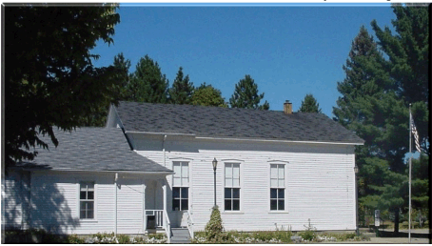
64255 Wolcott Road Ray Township, MI 48096
Phone: (586) 749-5171
Fax (586) 749-6190 Website www.raytownship.org
County of Macomb

Permanent Absent Voter Application Request List

The Ray Township Clerk’s Office maintains a master list of voters who are interested in receiving an application to request an Absent Voter Ballot prior to each election conducted in Ray Township.

If you are interested in being placed on this list, please complete the information in the box below and return this form to:
Lori Lascoe
Ray Township Clerk
64255 Wolcott
Ray, MI 48096

Placement on the Permanent Absent Voter Application List does not require that you vote an “absent voter ballot” for all future elections. Placement on the list assures that you will automatically receive, by U.S. Mail, an Absent Voter Application approximately one month prior to each election.

If you wish to vote at the polls, you simply do not complete or return the application you receive for that specific election.

DO NOT DETACH
PERMANENT ABSENT VOTER APPLICATION REQUEST FORM

Print Name__________________________________________________

Print Address________________________________________________

Birth ______/_____/_____

I request to receive an absent voter ballot application for all future elections held in Ray Township.

I understand that I must complete, sign, and return the application in order to have the absent voter ballot mailed to me.

Signature _____________________________________________Date_____________

