Location: Ray Township Hall
64255 Wolcott. Ray, MI 48096

Present: Tom Penzien, Chairman
Justin Lease, Vice-Chair
Randy Forro, Secretary
Members: Sharilyn Kaniuk
Justin Marberg
Doug Stier

Absent: John Zoccola (excused)

Also Present: Lisa Hall, Planning and Zoning Clerk,
Stephen Cassin, Township Planner.
Attendance record on file

1.CALL TO ORDER – PLEDGE OF ALLEGIANCE AND ROLL CALL.
Chairman Penzien called the meeting to order at 7:00 p.m. The Pledge of Allegiance was recited. Penzien, Marberg, Lease, Forro, Kaniuk, and Stier were present. Zoccola was absent.

2.APPROVAL OF MINUTES – February 12, 2019, amended.
MOTION by Stier supported by Lease to approve the February 12, 2019 minutes as presented.
MOTION carried.

3.APPROVAL OF AGENDA-
MOTION by Forro supported by Kaniuk to approve the agenda as presented.
MOTION carried.

4. SCHEDULED PUBLIC HEARINGS - none

5. NEW BUSINESS

5 A. Site Plan Application, Industrial, 67101 Brian Drive, Parcel 21-05-06-401-012, Mandarino Construction Brad White-Petitioner

Penzien explained the site plan review procedure, explaining planner will present his findings, correspondence will be read and will ask for any input from the applicant.
Penzien asked if applicant was in audience?

Brad White, applicant and Sal D’Anna engineer for project present stated names.

Cassin presented his findings to the board.

Site Plan Review

Zoning: I-1, Industrial
Location: West side of Brian Drive, North of 31 Mile Road
Property ID #: 21-05-06-401-012
Project Name: Mandarino Construction Storage Building
Case No: PCI-19-001
Applicant: Brad White
Review Date: March 28, 2019
Proposal
The applicant desires to construct a 4,950 square foot (90’ x 55’) industrial storage building (contractor equipment and supplies) on 3.7 acres on land, located at the northwest corner of Brian Drive and 31 Mile Road.
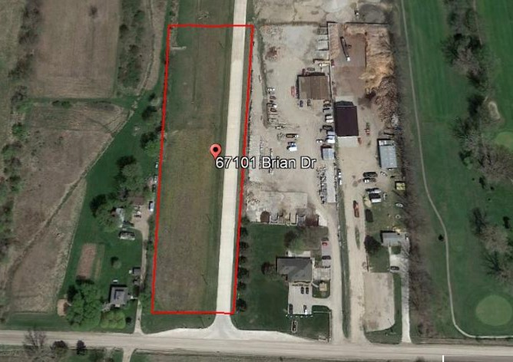
Aerial View of Subject Property
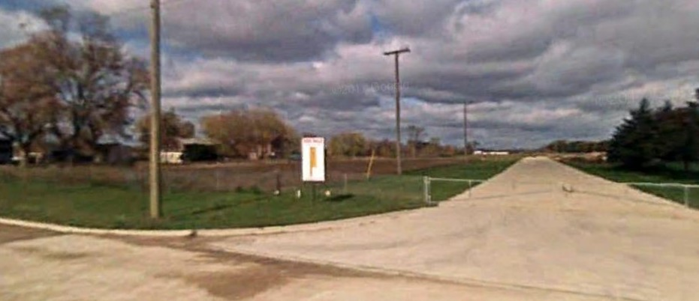
Street View of Subject Property

Compliance with the Zoning Ordinance

Section 1601 of the Ray Township Zoning Ordinance allows warehousing and storage buildings in the I-1 Light Industrial District as a principal use. The ordinance also requires compliance with several other requirements, which are detailed below:

Dimensional Requirements

 | Required | Proposed | Compliant
Front Yard Setback (31 Mile Road) | 110’ | 110.5’
Rear Yard Setback | 30’ | 616.1’
Side Yard Setback(s) | 15’ | 22’, 134’
Height | 35’ | 20’

Parking Requirements

 | Required | Proposed | Compliant
Standard Parking Spaces | 3 | 5
Barrier Free Parking Spaces | 1 | 1
Maneuvering Lane Minimum Width | 24’ | 24’
Parking Space Size | 10’ x 20’ | 10’ x 20’
Landscaping Requirements

 | Required | Proposed | Compliant
Parking Area Landscaping | Yes | Yes
Frontage Landscaping | 1 tree per 25’ of frontage | 6

Recommendation

Based on the above findings, I recommend approval of the site plan subject to compliance with all Township engineering, building, assessing, and fire department requirements, and all Macomb County requirements relative to roads, drainage, and septic.

Penzien stated all correspondence will be read into the record:

Penzien read correspondence received from Ray Township Fire and Rescue dated January 7, 2019 and March 26, 2019.

Lease read correspondence received from AEW, Lyle Winn, Ray Township engineer dated March 19, 2019.

Stier read correspondence received from Macomb County Public Works dated March 27, 2019

Forro read correspondence received from Macomb County Department of Roads dated March 22, 2019

Marberg read correspondence received from Ray Township Building Official Dennis LeMieux dated March 13, 2019

Penzien asked the applicant if he has seen the correspondence received?

D’Anna stated they have seen the comments and that Lyle Winn, AEW had a number of comments. Advised that upon approval they will start the construction documents and will changes to the drawings as required. Upon completion they will submit drawings to Lyle Winn, Public works and the Ray Township Fire Department.

Stier stated he has been in contact with Jim DiMaria, Ray Fire Chief regarding Knox box location as shown on site plan at front of building, Knox box should be located near the service door. Fire trucks will be entering off of Brain Drive and Knox box should be where fire would enter building.

D’Anna agreed that moving the Knox box location makes sense.

Stier questioned the location of the well as shown on the site plan? As shown, it projects into the parking area surrounded by some small shrubs, snowplowing could cause damage.

Penzien asked if the well location would have curb and gutter?

White advised the well needs to be at least fifty (50) feet from septic.

D’Anna stated the board makes a very good point related to the well location as shown and the possible hazards.

Forro asked where the North Property Line is located on the plan and is the dumpster located on the property line?

D’Anna stated the dumpster is located in the easement.

Penzien asked what is the proposed use for the rear of the property.

D’Anna stated they may seed the area and it will be used to park trucks and large equipment.

D’Anna stated a perk test has been done and field size has been established.

Lease asked why so much gravel is shown?

D’Anna gravel is a cost saving for the applicant, has concrete approaches and sidewalks.

Lease stated cost of hard surface can be significant.

Penzien stated all correspondence has been read. Applicant is aware of all items that need to be addressed.

Penzien stated he would seek a motion to approve, cannot table meets all Ray Township Zoning Ordinances.

MOTION by Marberg to supported by Stier to approve Site Plan for 67101 Brian Drive, Parcel 21-05-06-401-012, Mandarino Construction, Brad White, Petitioner, subject to compliance with all Township engineering, building, assessing, and fire department requirements, and all Macomb County requirements relative to roads, drainage, and septic.
FOR THIS MOTION: Yes: Marberg, Stier, Forro, Lease, Kaniuk, Penzien
No:
MOTION carried.

5B. 2018 Ray Township Planning Commission report:
MOTION by Stier supported by Lease to receive and file 2018 Ray Township Planning Commission report as presented.
MOTION carried.

6. Old Business: Capital Improvements Plan – nothing to report

7. PRESENTATION – None

8. REPORT OF THE BOARD REPRESENTATIVE:
Stier advised the Board approved proposal from Steve Cassin to update the Ray Township Parks and Recreation Master Plan. An updated plan enables the township to apply for grants and government funding.

Board adopted Ordinance #79 MINOR IN POSSESSION OF TOBACCO AND VAPOR PRODUCTS ORDINANCE
The ordinance helps law enforcement in helping to prevent minors from smoking and vaping. Attorney encouraged adoption of ordinance.

9. REPORT OF THE ZONING BOARD OF APPEALS REPRESENTATIVE: - Penzien advised that the ZBA has approved variances for accessory buildings to be located in front of the home in the past three months. The Ray Township zoning ordinance requires accessory structures be located behind the home.

Penzien asked Cassin if the ordinance should be less restrictive?

Cassin stated the Planning Commission put the ordinance in place and if a situation arises, a homeowner can request a variance from the ZBA.

Lease stated it is on a case by case basis.

Forro asked why did the Planning Commission have two (2) accessory buildings in front of new homes on Romeo Plank need Special Land use approval if they can go to the ZBA for a variance?

Marberg stated if the homes have not been constructed a Special Land Use is required.

Penzien stated there is a cost to apply to the ZBA.

10. CORRESPONDENCE – Berlin Township Master Plan

Cassin stated this is informational only, Berlin township is not required to notify Ray, not an adjacent community.

Penzien asked when the Planning Commission needs to review the Master Plan?

Cassin advised 2020.

11. PLANNING CONSULTANTS REPORT. -Cassin advised that a Parks and Recreation Master Plan is required by the state, and is required to receive state funding. The parks and recreation plan process will take between four (4) and five (5) months to complete and he will be seeking input from the Township Board and the Planning Commission.

12. PUBLIC COMMENTS – None

13. ADJOURNMENT.

MOTION by Stier supported by Marberg to adjourn the meeting at 7:35 p.m.
MOTION carried.

Tom Penzien, Chairman Randy Forro, Secretary Date

Respectfully submitted,
Lisa Hall, Recording Secretary

