TOWNSHIP OF RAY
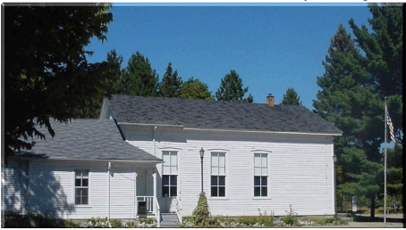
Board of Trustees
Joe Jarzyna, Supervisor
Lori Lascoe, Clerk
Douglas Stier, Treasurer
Charles Bohm, Trustee
Betty Grader, Trustee
64255 Wolcott Road Ray Township, MI 48096 (586) 749-5171
Fax (586) 749-6190 Website www.raytwp.org
County of Macomb

Zoning Board of Appeals Agenda
Date: Tuesday, June 25, 2019
Time: 7:00 p.m.
Location: 64255 Wolcott, Ray, MI 48096

Meeting Cancelled – No Agenda Items

Lisa Hall, Building, Planning and Zoning Director

