Location: Ray Township Hall
64255 Wolcott, Ray MI 48096

Present: Harold DeMan Jr., Chairman
Scott Mathews, Vice-Chairman
Members: Tom Penzien
Members: Betty Youngblood

Absent: Marvin DeBuck, Secretary - Excused

Also, Present: Steve Cassin, Planning Consultant & Lisa Hall, Planning & Zoning Clerk
Attendance record on file.

- CALL TO ORDER- PLEDGE OF ALLEGIANCE AND ROLL CALL.
Chairman DeMan called the meeting to order at 7:02 p.m. The Pledge of Allegiance was recited.
A quorum of the board was present.

- APPROVAL OF AGENDA
MOTION by Youngblood supported by Penzien to approve the agenda as presented.
MOTION carried.

- APPROVAL OF MINUTES: June 4, 2019 Special Meeting Minutes
MOTION Mathews supported by Youngblood to approve the meeting minutes of June 4, 2019 as presented.
MOTION carried.

- Scheduled Public Hearings-
1. Request to vary Section 400, Design Elements – Principal Structure, Yard Dimensions, Minimum Front Yard Setback. Request to vary Section 200, Accessory Buildings in Residential Districts, C, Maximum Size Limits at 65615 North Avenue, Parcel ID 21-05-11-400-004, Thomas Heldt, Applicant.

Chairman DeMan explained the public hearing procedure, the planner will explain the variance request so the audience will be informed on the variance request. Then the public hearing would be open for the public to come to the podium, state their name and address and state any comments they may have regarding the variance request.

MOTION by Penzien supported by Mathews to open the public hearing at 7:05 p.m.
MOTION carried.

Mr. Cassin, Planning Consultant presented his findings and recommendation dated July 14,2019 they are as follows:
GENERAL INFORMATION

Applicant: Thomas Heldt
Location: 65615 North Avenue
Zoning District: R-1, Agricultural Residential
Property ID: 21-05-11-400-004
Size of Parcel: 10.01 acres
Action Requested: Request variance of front yard setback, and maximum allowed square footage of accessory buildings.
PROPERTY CHARACTERISTICS

The property is located on the west side of North Avenue, north of 30 Mile Road. It is developed with a home, barn, and 6 accessory buildings.

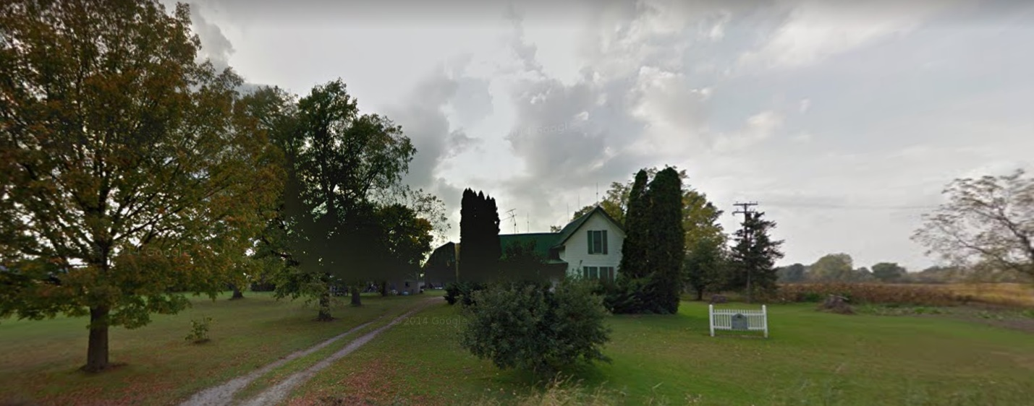

ANALYSIS OF VARIANCE REQUEST

As shown on the map below, the applicant is proposing dividing the land into 3 separate parcels. A 2.47-acre parcel with 165’ of frontage would be taken from the northern portion of the existing property, and a 2.47-acre parcel with 165’ of frontage would be taken from the southern portion of the existing property. The remaining parcel would be 5.08 acres and have a frontage of 339.87’.

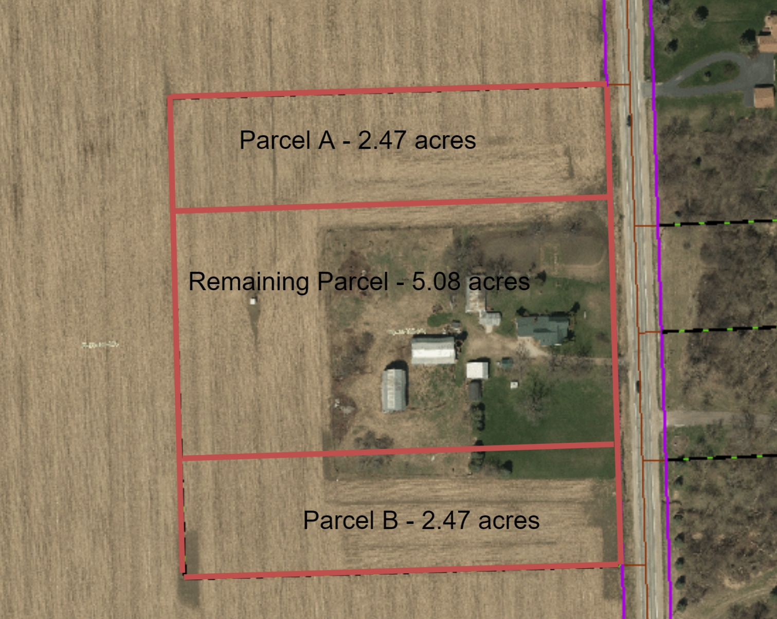

Section 6.00-E-1 of the Ray Township Land Division Ordinance states that no division of land shall be approved by the Township Assessor unless all township ordinance requirements, including zoning ordinance provisions, are met. In this regard, two variances are necessary.

Section 400 of the Ray Township Zoning Ordinance requires a minimum front yard setback of 110 feet from the center line of the road. The existing home is setback approximately 102 feet from the center line of the road. Therefore, a setback variance of 8 feet is required.

Section 200 of the Ray Township Zoning Ordinance limits the size of accessory buildings (on properties between 5 – 5.49 acres) to a total of 3,200 square feet. The total square footage of the 6 existing accessory structures is approximately 5,612 square feet. Therefore, an area variance of 2,412 square feet is required.

AUTHORITY OF THE ZONING BOARD OF APPEALS

Section 2706 of the Ray Township Zoning Ordinance specifies that variances may be granted if the Zoning Board of Appeals finds that:
- The strict enforcement of the Zoning Ordinance would cause practical difficulty and deprive the owner of rights enjoyed by all other property owners owning property within the same zoning district.
- The conditions and circumstances are unique to the subject property and are not similarly applicable to other properties in the same zoning district.
- The conditions and circumstances unique to the property were not created by the owner or his/her predecessors in title, within the time following the effective date of the provisions alleged to adversely affect such property.
- The requested variance will not confer special privileges that are denied other properties similarly situation and in the same zoning district.
- The requested variance will not be contrary to the spirit and interest of the Township Zoning Ordinance.

RECOMMENDATION

The existing conditions are unique to the property, have not been self-created, and are not contrary to the spirit and intent of the Zoning Ordinance. Therefore, I recommend approval of the 2 variances, as requested.
Chairman DeMan read correspondence as follows into the record:
July 17, 2019, Dennis LeMieux, Ray Township Building Official, the building department has no objections for a variance on this existing property.

7-16-2019 Kelly Timm, Ray Township Assessor, the assessing department has reviewed the request for the variances requested on the above referenced parcel.
In order to process the requested split, a variance is required for the front setback of the house. A variance is also required for exceeding the square footage of accessory buildings allowed on a 5.08-acre piece.
If approved, the variance would not cause any adverse impacts to the surrounding properties.
If you should have any questions regarding this information, please feel free to contact me.

Chairman DeMan asked the applicant if he had any questions?

Heldt asked if everyone that is selling a parcel has to go before the ZBA prior to the sale?

Cassin advised a variance is needed if you are creating parcels that do not comply with the zoning ordinance.

MOTION by Mathews supported by Penzien to close the public hearing at 7:09p.m.
MOTION carried.

Penzien asked Cassin if the road right of way is sixty (60‘) feet?

Cassin advised the North Avenue right of way is one hundred twenty (120‘) feet, sixty feet from the center line of the road, Ray Township adds fifty (50‘) feet making the front yard setback one hundred ten (110‘) feet. North Avenue is planned as a major throughfare.

Mathews stated the home on this parcel was built before the right of way was an issue.

MOTION by Penzien supported by Youngblood to approve both variances requested. Vary Section 400, Yard Dimensions, Minimum Front Yard Setback, to approve a setback variance of eight (8) feet for the existing home located within minimum front yard setback and to Vary Section 200, Accessory Buildings in Residential Districts, C, Maximum Size Limits, approving a variance for the existing accessory buildings to exceed the allowed square footage requiring a variance for 2,142 square feet at 65615 North Avenue, Parcel ID 21-05-11-400-004.
FOR THIS MOTION: YES: Penzien, Youngblood, Mathews, DeMan
NO: None
MOTION carried

5. Report from the Planning Commission Representative:
Penzien stated at the May 2019 Planning Commission meeting a site plan was approved contingent upon the recommendations of the engineer, planner, fire and other Macomb County departments. The planning commission may want to review the process.

6. Public Comments: None

7. Adjournment:
MOTION by Mathews supported by DeBuck to adjourn the meeting at 7:17 p.m.
MOTION carried.

Harold DeMan, Chairman Marvin DeBuck, Secretary Date

Respectfully submitted,
Lisa Hall, Recording Secretary

