TOWNSHIP OF RAY
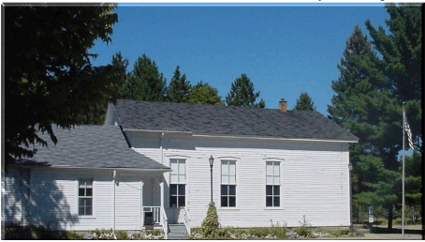
Board of Trustees
Joseph Jarzyna, Supervisor
Lori R. Lascoe, Clerk
Douglas C. Stier, Treasurer
Charles Bohm, Trustee
Betty Grader, Trustee
County of Macomb

64255 Wolcott Road Ray Township, MI 48096 (586) 749-5171
Fax (586) 749-6190 Website www.raytownship.org

2020 BUILDING USAGE AGREEMENT- Senior Center

ORGANIZATION:__________________________________________________________________

NAME:__________________________________________________PHONE:__________________

ADDRESS:__________________________________CITY:________________ZIP:_____________

ALTERNATE PHONE:__________________________________ E-MAIL:_____________________

DATE: DAY: TIME:

Please read the rules governing building usage and sign the acknowledgment on the reverse side of this document.
- Please use the park lane located on the north side of the building for parking.
- Permit holders are responsible for policing and cleaning the building after use. Please put trash in receptacles. Removal of stains on carpet from spilled beverages is your responsibility.
- Permit Applicant is responsible for any damages incurred by their group.
- Applicant must have permit in his possession on scheduled day of usage.
- Absolutely no alcoholic beverages or controlled substances are allowed in the building or grounds.

The holder of this permit shall indemnify, defend and hold harmless the Township, including Township officers, employees and agents, from and against all liabilities, losses, expenses, damages, fines, penalties, claims, suits and actions brought against the Township (including all related costs, actual and reasonable attorney fees and expenses) that result, directly or indirectly from the permit holder’s use of the premises specified in this permit.

Insurance – If required by the Township of Ray, the permit holder shall name the Township as an additional insured on any applicable Casualty or Liability Insurance.

I have read the above general rules governing the use of all Ray Township facilities and agree to have my group abide by them.

Signature of Permit Holder ______________________________ Date __________________

Approved by __________________________________________ Date __________________

