Location: Ray Township Hall
64255 Wolcott, Ray MI 48096

Present: Harold DeMan Jr., Chairman
Scott Mathews, Vice-Chairman
Marvin DeBuck, Secretary
Members: Tom Penzien
Betty Youngblood
Absent: None

Also Present: Steve Cassin, Planning Consultant & Lisa Hall, Planning & Zoning Clerk
Attendance record on file.

- CALL TO ORDER- PLEDGE OF ALLEGIANCE AND ROLL CALL.
Vice -Chairman Mathews called the meeting to order at 7:00 p.m. The Pledge of Allegiance was recited.
All members were present.

- APPROVAL OF AGENDA
MOTION by Penzien supported by Youngblood to approve the agenda as presented.
MOTION carried.

- APPROVAL OF MINUTES: July 23, 2019
MOTION by Mathews supported by Youngblood to approve the meeting minutes of July 23, 2019 as presented.
MOTION carried.

- Scheduled Public Hearings-
1. Request to vary Section 400, Design Elements – Principal Structure, Yard Dimensions, Minimum Front Yard Setback. Vary Section 200, Accessory Buildings in Residential Districts, C, Maximum Size Limits at 20289 31 Mile Road, Parcel 21-05-04-400-004, Fred Schienke, Applicant.

Chairman DeMan explained the public hearing procedure, the planner would explain the variance request so the audience will be informed on the variance request. Then the public hearing would be open for the public to come to the podium, state their name and address and state any comments they may have regarding the variance request.

MOTION by Penzien supported by Mathews to open the public hearing at 7:02 p.m.
MOTION carried.

Mr. Cassin, Planning Consultant presented his findings and recommendation dated October 14,2019 they are as follows:

GENERAL INFORMATION

Applicant: Frederick Schienke
Location: 20289 31 Mile Road
Zoning District: R-1, Agricultural Residential
Property ID: 21-05-04-400-004
Size of Parcel: 30.0 acres
Action Requested: Request variance of front yard setback, and maximum allowed square footage of accessory buildings.NALY
PROPERTY CHARACTERISTICS

The property is located on the north side of 31 Mile Road, between Wolcott and Hartway Roads. It is developed with a house, barn, and storage building.

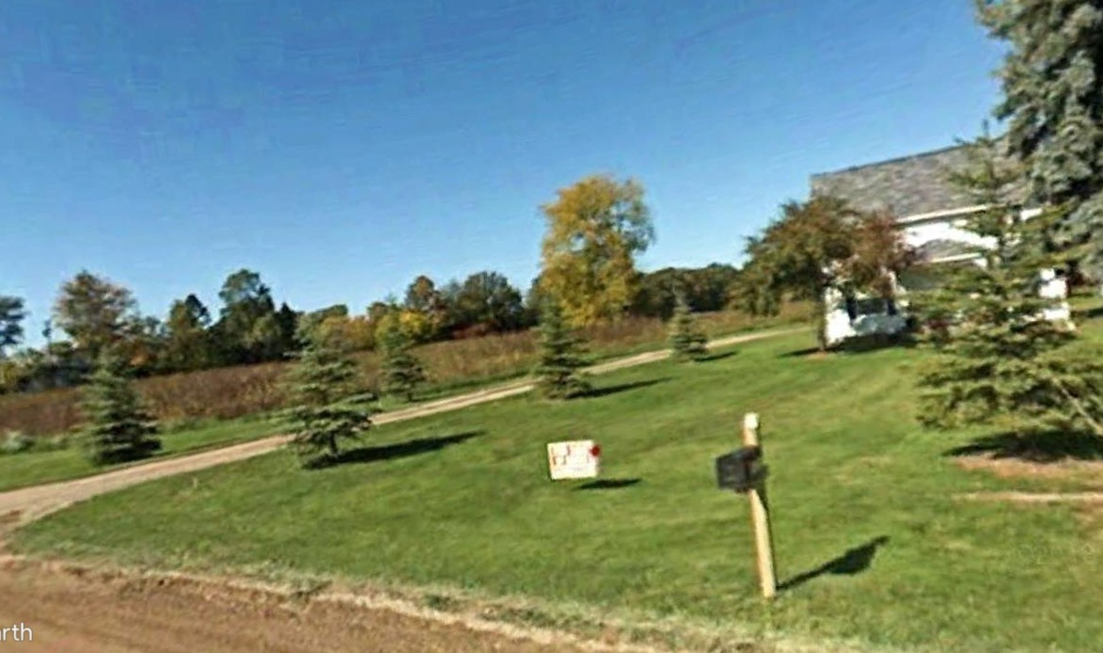
ANALYSIS OF VARIANCE REQUEST

As indicated on the maps below, the applicant is proposing dividing the land into 2 separate parcels. A 2.066-acre parcel with 165’ of frontage would be taken from the southeastern portion of the existing property. The remaining parcel would be 27.934 acres and have a frontage of 257.26’.
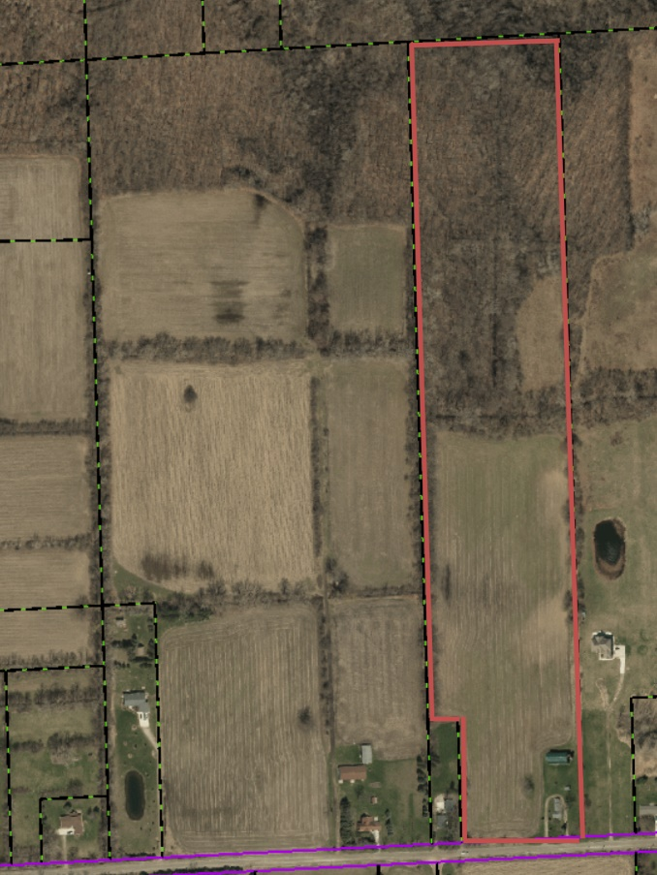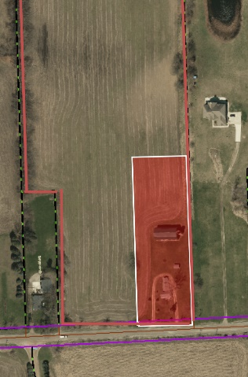

Parent Parcel – 30 Acres Proposed Parcel Split – 2.066 Acres

Section 6.00-E-1 of the Ray Township Land Division Ordinance states that no division of land shall be approved by the Township Assessor unless all township ordinance requirements, including zoning ordinance provisions, are met. In this regard, two variances are necessary.

Section 400 of the Ray Township Zoning Ordinance requires a minimum front yard setback of 110 feet from the center line of the road. The existing home is setback approximately 98.5 feet from the center line of the road. Therefore, a setback variance of 11.5 feet is required.

Section 200 of the Ray Township Zoning Ordinance limits the size of accessory buildings (on properties between 2.00 - 2.49 acres) to a total of 2,000 square feet. The total square footage of the 2 existing accessory structures is approximately 3,107 square feet. Therefore, an area variance of1,107 square feet is required.

AUTHORITY OF THE ZONING BOARD OF APPEALS

Section 2706 of the Ray Township Zoning Ordinance specifies that variances may be granted if the Zoning Board of Appeals finds that:
- The strict enforcement of the Zoning Ordinance would cause practical difficulty and deprive the owner of rights enjoyed by all other property owners owning property within the same zoning district.
- The conditions and circumstances are unique to the subject property and are not similarly applicable to other properties in the same zoning district.
- The conditions and circumstances unique to the property were not created by the owner or his/her predecessors in title, within the time following the effective date of the provisions alleged to adversely affect such property.
- The requested variance will not confer special privileges that are denied other properties similarly situation and in the same zoning district.
- The requested variance will not be contrary to the spirit and interest of the Township Zoning Ordinance.

RECOMMENDATION

The existing conditions are unique to the property, have not been self-created, and are not contrary to the spirit and intent of the Zoning Ordinance. Therefore, I recommend approval of the 2 variances, as requested.

DeMan read correspondence as follows:

10-9-2019 Dennis LeMieux, Building Official advised the Building Department has no objections to the requested variance for the split.

10-10-2019 Kelly Timm, Ray Township Assessor, the assessing department has reviewed the request for the variances requested on the above referenced parcel.
In order to process the requested split, a variance is required for the front setback of the house. A variance is also required for exceeding the square footage of accessory buildings allowed on the proposed 2.066-acre piece.

If approved, the variance would not cause any adverse impacts to the surrounding properties.

If you should have any questions regarding this information, please feel free to contact me.

DeMan asked the applicant if he had any comment?

Applicant representative had no comments or questions.

Penzien asked other members if there was any discussion.

MOTION by DeBuck supported by Youngblood to close the public hearing at 7:07 p.m.
MOTION carried.

MOTION by Penzien supported by DeBuck to approve the request to vary section 400, Design Elements – Principal Structure, Yard Dimensions, Minimum Front Yard setback, existing home required setback variance of 11 ½ feet to meet ordinance. Approve the request to vary Section 200, Accessory Buildings in Residential Districts, C, Maximum Size Limits, existing buildings required an area variance of 1,107 square feet to meet the ordinance, at 20289 31 Mile Road, Parcel # 21-05-04-400-004.
FOR THIS MOTION: YES: Penzien, DeBuck, Mathews, Youngblood, DeMan
NO: None
MOTION carried.

5. Report from the Planning Commission Representative:
Penzien stated that no planning commission meetings have been held in September or October, no agenda items.

DeBuck asked what is the construction on 29 Mile?

DeMan stated it is the Cutro Estates – Private Road containing 8 parcels.

DeBuck asked if the private road is located on the East side of the parcel?

Mathews stated the parcel is not wide enough to put homes on the East Side of the road.

DeMan stated the road has to be complete before any permits for homes will be issued.

Cassin stated the road has to be completed to meet engineering standards and Macomb County Department of Roads standards for permits can be issued.

Mathews stated the work in progress is all storm sewer.

6. Public Comments: None

7. Adjournment
MOTION by Mathews supported by Penzien to adjourn the meeting at 7:14p.m.
MOTION carried.

Harold DeMan, Chairman Marvin DeBuck, Secretary Date

Respectfully submitted,
Lisa Hall, Recording Secretary

