TOWNSHIP OF RAY
Board of Trustees
Joseph Jarzyna, Supervisor
Lori Lascoe, Clerk
Doug Stier, Treasurer
Charles Bohm, Trustee
Betty Grader, Trustee
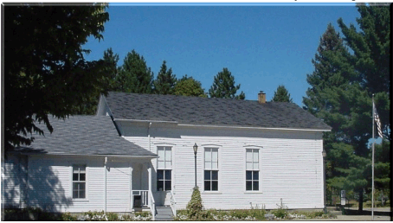
64255 Wolcott Road Ray Township, MI 48096
Phone: (586) 749-5171
Fax (586) 749-6190 Website www.raytownship.org
County of Macomb

During the Declared State of Emergency

Building permits, Inspections and Burn permits can utilize the Township website and drop box for applications for essential services.

Documents can be emailed to departments using addresses listed below or placed in the secure blue drop box located near the steps to the Township Office. (Mail and drop box items are picked up Mon-Thurs.) Please ensure there is contact information on all documents placed in the drop box, including name, phone, email and mailing address.

For information by phone, please call 586-749-5171 ext. 8 under department directory. Essential employees are in Monday-Thursday.

Supervisor Joe Jarzyna – Supervisor@Raytwp.org Ext. 202
Clerk Lori Lascoe – Clerk@Raytwp.org Ext. 201
Treasurer Doug Stier – Treasurer@Raytwp.org Ext. 205
Departments
Assessor, Kelly Timm – KTimm@Raytwp.org Ext. 207
Building Department , Lisa Hall – LHall@Raytwp.org Ext. 203
Burn Permits – Info@Raytwp.org
Elections – Clerk@Raytwp.org

