TOWNSHIP OF RAY
Board of Trustees
Joseph Jarzyna, Supervisor
Lori Lascoe, Clerk
Doug Stier, Treasurer
Charles Bohm, Trustee
Betty Grader, Trustee
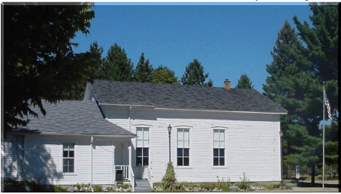
64255 Wolcott Road Ray Township, MI 48096 Phone: (586) 749-5171
Fax (586) 749-6190 Website www.raytownship.org
County of Macomb

BOARD OF TRUSTEES AGENDA

Date: Wednesday, August 19, 2020

Time: 7:00 p.m.

Location: Electronic Remote Access with Zoom – Meeting ID: 597 725 0966
Password: 642075

- CALL TO ORDER – PLEDGE OF ALLEGIANCE AND ROLL

- APPROVAL OF AGENDA

- CORRESPONDENCES:

- PUBLIC COMMENTS – For Agenda Items - Members of the public will only be able to speak during the public comments portion of the meeting and such comment will be limited to three minutes per person. To provide for orderly public participation, a person wishing to speak must virtually raise their hand to be recognized by the Township Supervisor. The Supervisor will recognize all persons wishing to speak during public comments.

- APPROVAL OF MINUTES – July 21, 2020

- APPROVAL OF BILLS

- OFFICER’S REPORTS
  - Supervisor
  - Clerk
  - Treasurer
  - Trustees

- DEPARTMENT REQUEST/REPORTS
  - Assessing Report
  - Budget Report
  - Building Department
  - Fire Department Report
  - Library Report
  - SMART/Richmond Lenox EMS Report

- UNFINISHED BUSINESS

- NEW BUSINESS
  - Fire Department compensation for attending both morning and evening training.
  - Request to advertise for Staff Assistant position.
  - Request to dispose of old printer.
  - Review 2021 Single Waste Hauler Collection and Disposal Program and Proposal Form.
  - Request to attend Michigan Municipal Treasurers Association Conference.

- PUBLIC COMMENTS

- ADJOURNMENT
1

Respectfully submitted,

Lori R. Lascoe
Ray Township Clerk

Posted Tuesday, August 18, 2020 at 10:37a.m. Township Display Case

