TOWNSHIP OF RAY
Board of Trustees
Joe Jarzyna, Supervisor
Lori Lascoe, Clerk
Betsy Bart, Treasurer
Betty Grader, Trustee
Douglas Stier, Trustee
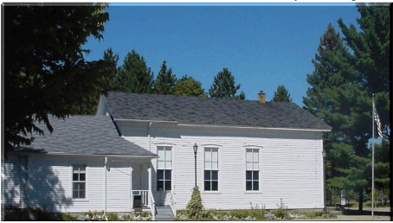
Building Department
64255 Wolcott Road, Ray Township, MI 48096 (586) 749-5171
Building Department Ext 203
Fax (586) 749-6190 Website www.raytwp.org

BUILDING ADDITION REQUIREMENTS

1. COMPLETED AND SIGNED BUILDING PERMIT APPLICATION FORM.
2. COMPLETED AND SIGNED CERTIFICATE OF ZONING COMPLIANCE.
3.THREE (3) SETS OF PLANS showing footings (see attached) Plans must be no larger than 24” X 36” (Standard Size)

4. THREE (3) SITE PLANS indicating size of addition, distance from property lines, easements, out buildings, septic and well. (See Attached) Plans must be no larger than 24” X 36” (Standard Size)

5. HOMEOWNERS PERMIT (Estoppel Certificate) or CURRENT BUILDERS LICENSE REQUIRED. Builder to furnish letter authorizing application letter authorizing signer if not same name. Builder to furnish: Federal employer I.D.#, M.E.S.C. Employer #, Copy of Workman’s Compensation Insurance and Liability Coverage, Driver’s License # and date of birth.

6. *Additions to existing residence requires Macomb County Health Department approval if adding bedrooms.

7. CZC & PLAN REVIEW APPLICATION FEE: Due with application. (NON-REFUNDABLE).
ADDITIONS 500 SQ. FT. AND OVER $150.00
ADDITIONS 3,500 SQ. FT AND OVER $400.00

8. PERFORMANCE BOND required when permit is issued
500 SQ.FT. To 3,499 SQ. FT. - $1,000.00
3,500 SQ.FT. AND OVER - $2,000.00

PERMIT FEE, REQUIRED INSPECTION FEES AND BOND DUE WHEN PERMIT IS ISSUED. BOND AND PERMIT FEE IF PAID BY CHECK MUST BE TWO SEPARATE CHECKS.

*Macomb County Health Department
21777 Dunham Road
Mt. Clemens, MI 48043
Phone (586) 469-5512
Fax (586) 469-5885
Web : health.macombgov.org

