TOWNSHIP OF RAY
Board of Trustees
Joe Jarzyna, Supervisor
Lori Lascoe, Clerk
Betsy Bart, Treasurer
Betty Grader, Trustee
Douglas Stier, Trustee
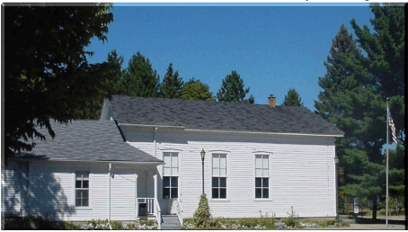
Building Department
64255 Wolcott Road, Ray Township, MI 48096 (586) 749-5171
Building Department Ext 203
Fax (586) 749-6190 Website www.raytwp.org

POND PERMIT REQUIREMENTS

1. COMPLETED AND SIGNED BUILDING PERMIT APPLICATION FORM.
2. COMPLETED AND SIGNED CERTIFICATE OF ZONING COMPLIANCE.
3.SITE PLAN (3 COPIES)

4. CZC & PLAN REVIEW APPLICATION FEE: $100.00 Due with application. (NON-REFUNDABLE).

5. PERMIT FEE: Required when permit is issued. See fee schedule attached.

6. PERFORMANCE BOND: $500.00 required when permit is issued

PERMIT FEE, REQUIRED INSPECTION FEES AND BOND DUE WHEN PERMIT IS ISSUED. BOND AND PERMIT FEE IF PAID BY CHECK MUST BE TWO SEPARATE CHECKS.

Farm, fish and recreation ponds or aesthetic landscaping ponds, subject to the following:

1. A site plan shall be submitted and approved by the building inspector.

2. Ponds shall only be of an excavation type, as defined by the Soil Conservation Service engineering standard, and all ponds shall be construction to the SCS Standards (see standard 378 of the Soil Conservation Service, as amended).

3. No commercial activities, including public fishing, shall be allowed.

4. The pond shall be a minimum distance of fifty (50’) feet from the property line of any abutting lands.

5.In the event the owner wishes to sell the excavated materials off the site, he shall conform with the requirements of the mining and extraction ordinances of the township.

6. Any artesian well or other water overflow from a pond that could affect adjacent property shall be provided with adequate drainage.

7. Ponds shall be a minimum of ten (10’) feet deep over twenty-five (25%) percent of the ponds surface area.

8. Ponds shall be located a minimum of one hundred (100’) feet from the septic tank or field.

9. Contaminated surface water shall be diverted around all ponds.

10. Ponds shall be constructed in such a manner that runoff, overflow, spillage or seepage shall not encroach upon adjacent properties owned by another person.

11.Ponds shall have warning signs and lifesaving equipment, as required by the State of Michigan:
a. Required sign – “WARNING DEEP WATER” – Signs are available at the Township office for a cost of $5.00 each.
b. Life ring with rope you can throw to the middle of the pond.

12. Fifty (50’) feet from well.

