TOWNSHIP OF RAY
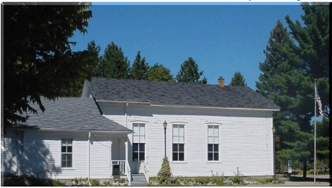
Board of Trustees
Joseph Jarzyna, Supervisor
Lori R. Lascoe, Clerk
Betsy Bart, Treasurer
Betty Grader, Trustee
Doug Stier, Trustee
County of Macomb

64255 Wolcott Road Ray Township, MI 48096 (586) 749-5171
Fax (586) 749-6190 Website www.raytownship.org

2022 PAVILION RENTAL AGREEMENT

NAME: __________________________________________________________________________

ADDRESS: __________________________________CITY: _______________ZIP: _____________

PHONE: _____________________________ALTERNATE PHONE: __________________________

E-MAIL: _________________________________________________________________________

NAME / MESSAGE ON SIGN: ________________________________________________________

DATE | DAY | TIME | PAVILION | APP. # OF PEOPLE
 |  |  | 1 2 3

FEES: (Fees are charged per pavilion)
PARK MAINTENANCE FEE
($50 RESIDENT, $100 NON-RESIDENT) __________

REFUNDABLE DEPOSIT ($100) __________

TOTAL __________

Please read the rules governing park usage and sign the acknowledgment on the next page of this document.

- No cars or other motorized vehicles shall be permitted around the pavilions. Please use the park lane for parking which is located on the north side of the building.
- Full payment is due upon request of this permit.
- Permit holders are responsible for policing and cleaning the pavilion after use. Please put trash in receptacles. Any cleaning or maintenance required by the township will be deducted from your deposit.
- Applicant is responsible for any damages incurred by their group.
- Applicant must have permit in his possession on scheduled day of usage.
- Park is closed at dusk. Pavilion is available from 9AM until dusk.
- You may hang signs and decorations but no nails, staples or duct tape is permitted to be used. Please remove all tacks and tape or a $25 fee will be deducted from your deposit.
- Each pavilion has 3 picnic tables that accommodate approximately 30 persons. Bring additional tables and chairs if necessary.
- Permission must be obtained from the Township prior to assembly of tents, canopies and portable restrooms. Request must be made in a written format two weeks prior to the rental.
- Request for a reservation of pavilions can be made one year in advance for residents and begin March 1st for non-residents.
- Electricity in pavilion #2 is available upon request.
- No overnight camping is allowed.
- Refunds of park maintenance fees are issued in emergency situations only.
- Absolutely no alcoholic beverages or controlled substances are allowed in the park.

*****To report facilities problems; please call the Township Office during regular business hours
Monday-Thursday 8:30 a.m.-4:30 p.m. (586) 749-5171 ext. 204.

The holder of this permit shall indemnify, defend and hold harmless the Township, including Township officers, employees and agents, from and against all liabilities, losses, expenses, damages, fines, penalties, claims, suits and actions brought against the Township (including all related costs, actual and reasonable attorney fees and expenses) that result, directly or indirectly from the permit holder’s use of the premises specified in this permit.

Insurance – If required by the Township of Ray, the permit holder shall name the Township as an additional insured on any applicable Casualty or Liability Insurance.

I have read the above general rules governing the use of all Ray Township pavilions and agree to have my group abide by them.

Signature of Permit Holder __________________________________________Date ___________

Approved by _____________________________________________________Date ___________

For Office Use Only:

Rental Fee | Deposit | Total | Check # or Cash Received

